**Chemistry**

**YOUR CHOICES + YOUR ACTIONS = YOUR FUTURE!!!**

**Packet#4**

**Unit#4: Arrangement of Electrons in Atoms**

(BRING THIS WITH YOU TO EVERY CLASS)

*“Genius is 1% inspiration and 99% perspiration.” – Thomas Edison*

***Edmodo Group Code:*** *ozm60q* (http://www.edmodo.com)

***Class Website:*** http://mrgchem.weebly.com

***Mr. Gutierrez’s email:*** gutierrezbr@elizabeth.k12.nj.us

Text Messaging Reminders: Text @aofchem to 23559

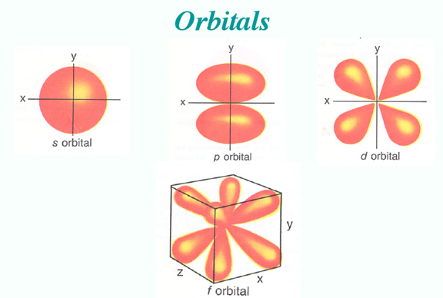 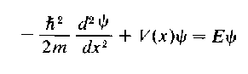

*Note: You are expected to work on this packet during the allotted class practice time.*

|  |  |  |  |  |
| --- | --- | --- | --- | --- |
| **Packet** | | **Followed All Classroom Policies** | | **Class work Participation** |
| /35 | Completed Class Notes | / | Monday | / |
| /35 | Completed Classwork | / | Tuesday | / |
| /5 | Writing Name on Every Page | / | Wednesday | / |
| /25 | Handed Packet in on Time | / | Thursday | / |
| /100 | Total Points | / | Friday | / |
|  |  | / | Total Points | / |

Name of Chemist:

________________________________________________________________________

Period: ___________

*\*All Classnotes + Questions MUST be finished for HOMEWORK if not done in class.*

***DUE _________________________***

**INCREASING ENERGY**

**Unit#4: Arrangement of Electrons in Atoms**

***Table of Contents***

|  |  |  |  |
| --- | --- | --- | --- |
| **Topic** | **Pages** | **Textbook Pages** | **Supplementary Materials**  **(Video or Notes)** |
| Aufbau Principle, Hund’s Rule, Pauli Exclusion Principle | 3 - 4 | 111 - 112 |  |
| Electron Configuration: – Orbital Notation | 4 | 112 - 113 |  |
| Electron Configuration: – Electron-Configuration Notation | 9 - 13 | 116 - 117 |  |
| Electron Configuration: – Noble Gas Notation | 14 – 15 | 117 – 122 |  |
| Electron Configuration Summary | 16 - 19 | 111 - 122 |  |
| Quantum Numbers | 20 - 22 | 107 - 110 |  |

**Additional Resources:**

**\*Tutoring with Mr. Gutierrez:** Meet Mr. Gutierrez in student cafeteria after school or during 10th period.

|  |
| --- |
| **Date: _________________**  **Objectives: 1) SWBAT describe Hund’s Rule, the Aufbau Principle, and the Pauli Exclusion Principle. 2) SWBAT draw the orbital notation of a neutral atom using electron configuration rules.** |
|  |

***Electron Configuration***

* So Niels Bohr was right. According to Bohr, _____________ move around the ___________ at certain energy levels, but it becomes a little more complicated.
* Within these levels, we have **orbitals**, or energy sublevels, which are regions ______________________________________.

Electron configuration describes ___________________________________________________.

Why does this matter?

Knowing the electron configuration of an atom can help _____________________________________________________________________________________.

***The Three Ways of Writing Electron Configuration are:***

1. Orbital Notation
2. Electron Configuration Notation
3. Noble Gas Notation

When describing the way electrons are arranged, you MUST remember THREE IMPORTANT RULES that govern electron configuration.

**1. *Aufbau Principle***

* **ELECTRONS ENTER ORBITALS OF _______________ ENERGY FIRST**
* Aufbau is German for “building up, construction”

**1s 2s 2p 3s 3p 4s 3d** 4p 5s 4d 5p 6s 4f 5d 6p 7s 5f 6d 7p

**INCREASING ENERGY**

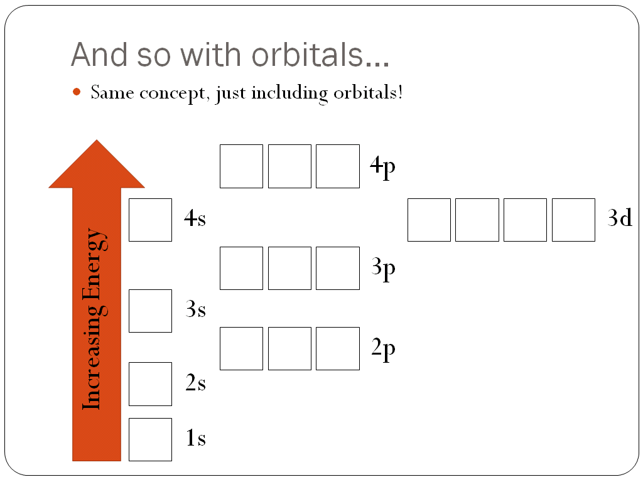

**2. *Pauli Exclusion Principle***

* **ONLY _______ ELECTRONS CAN OCCUPY AN __________**
  + “Two to a seat!”
* The electrons in those “pairs” have to **must have _____________spins**
  + “Makes ‘em fit!”



***Hund’s Rule***

* WHEN ELECTRONS OCCUPY AN ORBITAL OF EQUAL ENERGY, ELECTRONS FILL ORBITALS ONE BY ONE **BEFORE PAIRING UP.**
* One by one first and THEN they “buddy up”
  + Because if you could have a seat to yourself, you’d take that before having to cram in with someone else! Right?



**ORBITAL NOTATION**

1. An orbital is represented by ________________ or ______________.
2. Electrons are represented by ____________________.

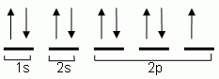

Examples:

Draw the orbital notation of a neutral (name of element) atom.

|  |  |
| --- | --- |
| Flourine |  |
| Calcium |  |
| Carbon |  |

**Additional Notes/Summary:**

|  |
| --- |
| **Date: _________________**  **Objectives: 1) SWBAT describe Hund’s Rule, the Aufbau Principle, and the Pauli Exclusion Principle. 2) SWBAT draw the orbital notation of a neutral atom using electron configuration rules.** |

***Class Work (Independent Practice):*** Finish as many questions as you can during class. Refer to your notes and ask at least three classmates before asking me for help. If you do not finish these questions in class, you must finish them for homework.

*Write the orbital notation for the neutral atoms of the following elements. Do not forget your three rules.*

1. Calcium
2. Argon
3. Strontium
4. Potassium
5. Magnesium

**Once you are finished, have Mr. Gutierrez check your work.**

**Lithium** has _____ electrons. Therefore, you have _____ electrons to “place.” We indicate electrons on these diagrams by _____________.

*Lithium’s diagram:*

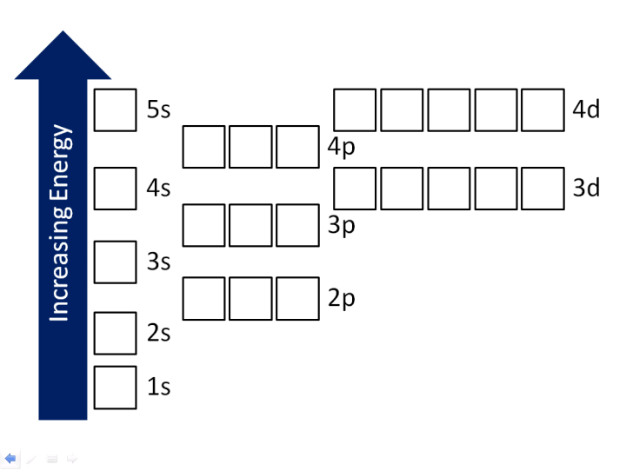

__________________________________________________________________________________________________

**Nitrogen** has _____ electrons.

__________________________________________________________________________________________________

**Neon** has _____ electrons.

__________________________________________________________________________________________________

**Sodium** has _____ electrons.

__________________________________________________________________________________________________

**Phosphorous** has _____ electrons.

__________________________________________________________________________________________________

**Calcium** has _____ electrons.

__________________________________________________________________________________________________

**Titanium** has _____ electrons.

|  |
| --- |
| **Date: _________________**  **Objectives: SWBAT write the electron configuration of a neutral atom using electron configuration rules.** |

**Electron Configuration Notation**

***The Three Ways of Writing Electron Configuration are:***

1. Orbital Notation
2. **Electron Configuration Notation**
3. Noble Gas Notation

***Let’s step it up a notch!***

Scientists like to keep things nice and neat, efficient and convenient. When talking about electrons and where they are located, they would not want to draw out all those boxes, so we have a more efficient means of doing it. We write out ***electron configurations*** for elements in a more condensed, shorthand manner. We simply take what we see in those boxes and write it all on one line.

So for Lithium (you already drew its diagram):

1s22s1

And for Titanium (you already drew its diagram):

1s22s22p63s23p63d24s2

Please note that the ***superscripts*** (above the script) add up to the number of electrons. Also, even though we fill the ***4s*** orbital before ***3d***, we write 3d first, by convention.

**Please fill out the diagram and write the electron configurations (EC) for the following elements.**

**Helium, He**

*# electrons:* _____

*EC:* _________________________________________ *Superscripts add up?* _____

**Boron, B**

*# electrons:* _____

*EC:* _________________________________________ *Superscripts add up?* _____

**Fluorine, F**

*# electrons:* _____

*EC:* _________________________________________ *Superscripts add up?* _____

**Magnesium, Mg**

*# electrons:* _____



*EC:*_________________________________________ *Superscripts add up?* _____

**Argon, Ar**

*# electrons:* _____

*EC:* _________________________________________ *Superscripts add up?* _____

***Let’s step it up a notch, again!***

Please try it without drawing the energy level diagram. Write the electron configurations for the following. Need some help? Follow the path!

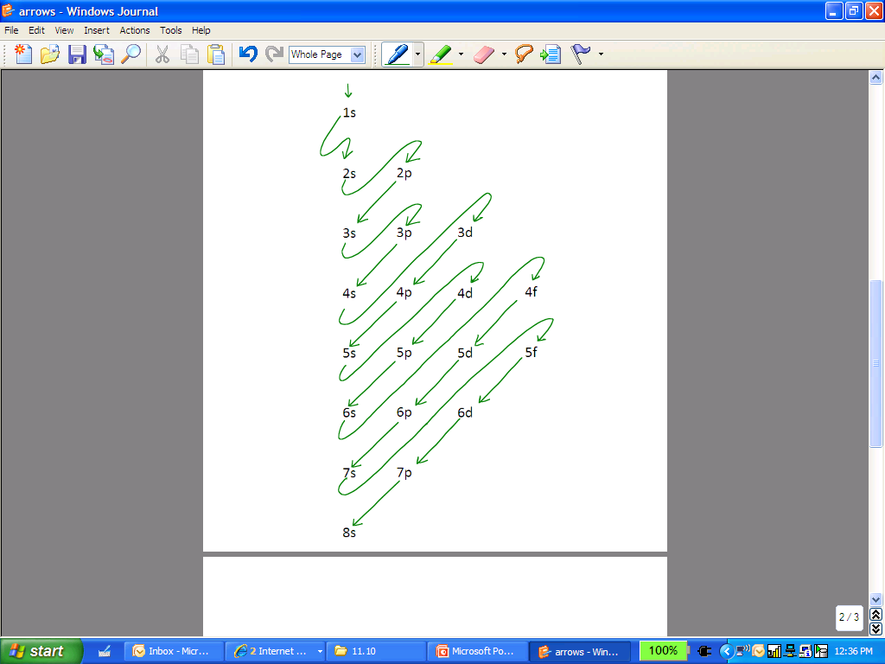

|  |  |  |
| --- | --- | --- |
| Element | # Electrons | Electron Configuration (EC) |
| Lithium, Li |  |  |
| Beryllium, Be |  |  |
| Carbon, C |  |  |
| Nitrogen, N |  |  |
| Fluorine, F |  |  |
| Magnesium, Mg |  |  |
| Aluminum, Al |  |  |
| Chlorine, Cl |  |  |
| Rubidium, Rb |  |  |
| Sodium, Na |  |  |
| Scandium, Sc |  |  |
| Titanium, Ti |  |  |

__________________________________________________________________________________________________

***Exceptions to the rule!***

The Aufbau Principle takes us through vanadium pretty easily. Once we hit chromium (Cr), though, we encounter an exception to the rule! We would incorrectly give chromium the electron configuration of

1s22s22p63s23p63d44s2

Actually, chromium would prefer to have a half-full 3d orbital than a full 4s orbital. It feels more stable that way. Therefore, its correct configuration is:

1s22s22p63s23p63d54s1

Same thing goes for copper. We would incorrectly give copper a full 4s orbital and a 3d orbital with 9 electrons (almost to a full 10), as follows:

1s22s22p63s23p63d94s2

Really, copper would prefer a full 3d orbital over a full 4s orbital, as follows:

1s22s22p63s23p63d104s1

***Keep it going!!!***

Please write the EC for the following elements.

|  |  |  |
| --- | --- | --- |
| Element | # e- | Electron Configuration (EC) |
| Ca |  |  |
| Sr |  |  |
| Ti |  |  |
| Cr |  |  |
| Fe |  |  |
| Se |  |  |
| Rh |  |  |
| Ag |  |  |
| Br |  |  |
| Ba |  |  |
| Fr |  |  |
| U |  |  |
| Mo |  |  |
| Hf |  |  |
| Am |  |  |
| Cf |  |  |
| Es |  |  |
| Au |  |  |
| Rn |  |  |
| Lr |  |  |

|  |
| --- |
| **Date: _________________**  **Objectives: SWBAT use the electron configuration rules to write the electron configuration of a neutral atom using Noble Gas Notation.** |
|  |

**Noble Gas Notation**

***The Three Ways of Writing Electron Configuration are:***

1. Orbital Notation
2. Electron Configuration Notation
3. **Noble Gas Notation**

**______________ __________** are located in **_______________.**

**Examples:**

**1.**

**2.**

**3.**

|  |
| --- |
| **Date: _________________**  **Objectives: SWBAT use the electron configuration rules to write the electron configuration of a neutral atom using Noble Gas Notation.** |
|  |

**Electron Configuration: Noble Gas Notation**

Write the electron configuration of the following neutral atoms using Noble Gas Notation.

1. Be

1. H
2. B
3. Cl
4. Mg
5. K
6. Ne

8. Si

9. Na

1. S

**Electron Configuration Summary**

|  |  |  |
| --- | --- | --- |
| **Aufbau**  **Principle** | **Pauli Exclusion Principle** | **Hund’s Rule** |
| Electrons enter orbitals of **lowest** energy first | Only TWO electrons can occupy an orbital and they must have OPPOSITE spins. | When electrons occupy an orbital of equal energy, electrons fill orbitals one by one before pairing up. |
|  |  |  |

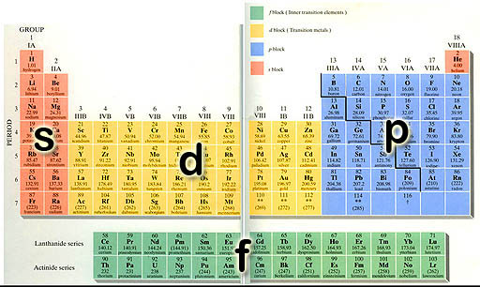

|  |  |  |  |  |  |  |  |  |  |  |  |  |  |  |  |  |  |
| --- | --- | --- | --- | --- | --- | --- | --- | --- | --- | --- | --- | --- | --- | --- | --- | --- | --- |
| **1s** |  | | | | | | | | | | | | | | | | **1s** |
| **2s** |  |  | | | | | | | | | |  |  | **2** | **p** |  |  |
| **3s** |  |  |  | **3** | **p** |  |  |
| **4s** |  |  |  |  |  | **3** | **d** |  |  |  |  |  |  | **4** | **p** |  |  |
| **5s** |  |  |  |  |  | **4** | **d** |  |  |  |  |  |  | **5** | **p** |  |  |
| **6s** |  |  |  |  |  | **5** | **d** |  |  |  |  |  |  | **6** | **p** |  |  |
| **7s** |  |  |  |  |  | **6** | **d** |  |  |  |  |

|  |  |  |  |  |  |  |  |  |  |  |  |  |  |
| --- | --- | --- | --- | --- | --- | --- | --- | --- | --- | --- | --- | --- | --- |
|  |  |  |  |  |  | **4** | **f** |  |  |  |  |  |  |
|  |  |  |  |  |  | **5** | **f** |  |  |  |  |  |  |

|  |
| --- |
| **Date: _________________**  **Objectives: SWBAT use the electron configuration rules to write the electron configuration of a neutral atom using orbital notation and electron configuration notation.** |
|  |

**Electron Configuration**

1. **Instructions:** Write the electron configuration and draw the planetary model (Bohr mdoel) for the following three elements.

|  |  |  |
| --- | --- | --- |
|  | **Electron Configuration** | **Bohr Model** |
| Helium |  |  |
| Carbon |  |  |
| Vanadium |  |  |

1. **Instructions:** Label the four sections of the Periodic Table as S, P, D, and F.
2. **Instructions:** Below is the electron configuration of Helium. Label each part as the shell, orbital or number of electrons.

1s2

1. **Instructions:** Write the electron configuration and orbital configuration of each of the following

|  |  |  |
| --- | --- | --- |
|  | **Electron Configuration** | **Orbital Configuration** |
| Helium |  |  |
| Hydrogen |  |  |
| Carbon |  |  |
| Oxygen |  |  |
| Aluminum |  |  |
| Chlorine |  |  |
| Vanadium |  |  |
| Nickel |  |  |
| Calcium |  |  |
| Germanium |  |  |
| Krypton |  |  |

|  |
| --- |
| **Date: _________________**  **Objectives: 1) SWBAT list the four quantum numbers and describe their significance.** |
|  |

Class Notes:

**Quantum Model of the Atom and Quantum Numbers**

Currently, chemists and physicists accept the quantum model of the atom. The Heisenberg uncertainty principle and the Schroedinger wave equation laid the foundation for modern quantum theory. ***Quantum theory*** describes mathematically the _________ ______________ of _____________ and other very small ___________.

Quantum numbers specify the ________________ of atomic __________ and the properties of ___________ in ____________.

Electrons are found in ____________________ according to quantum theory.

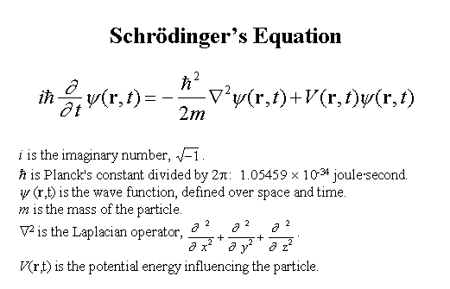

|  |  |  |  |
| --- | --- | --- | --- |
| *Quantum Number* | What It Tells You | Symbol | Numerical Values |
| **Principal** |  |  |  |
| **Angular Momentum** |  |  |  |
| **Magnetic** |  |  |  |
| **Spin** |  |  |  |

**Orbitals come in different shapes and sizes!**

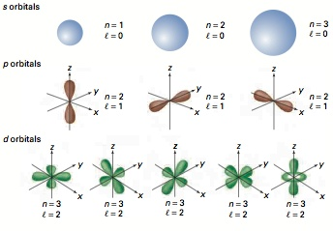

|  |  |  |
| --- | --- | --- |
| **Angular momentum value l** | **Letter** | **Shape** |
|  |  |  |
|  |  |  |
|  |  |  |
|  |  |  |

|  |
| --- |
| **Date: _________________**  **Objectives: 1) SWBAT list the four quantum numbers and describe their significance.** |
|  |

# **Getting to Know your Quantum Numbers**

1. **What does each of the four quantum numbers represent?**

|  |  |
| --- | --- |
| **Quantum #** | **What it represents** |
| **1** |  |
| **2** |  |
| **3** |  |
| **4** |  |

1. **What energy level is Neon’s last place electron in? ________________________**
2. **How many electrons can the 7th energy level hold? ________________________**
3. **What is the max number of energy levels that we would need in order to hold all of the electrons in element 118? Try to explain why we have more than we need.**
4. **Please complete the following table concerning the second quantum number:**

|  |  |  |  |
| --- | --- | --- | --- |
| **Sub NRG Level** | **Shape** | **Max # of electrons** | **# of Orbitals** |
| **S** |  |  |  |
| **P** |  |  |  |
| **D** |  |  |  |
| **F** |  |  |  |

1. **What is an orbital? _____________________________________________________________**
2. **Draw the three confirmations of a p subenergy level.**
3. **What is the spin on the last filled electron in each of the following:**

**Ba: __________ Re: __________ S: __________ Am: __________**

Make sure Mr. Gutierrez stamps/signs this by the end of the period. You CANNOT get the stamp/signature for a day later on. It is your responsibility to remind Mr. Gutierrez. You will NOT receive a stamp if you did not follow all classroom policies or actively work on the practice problems during the allotted class time.A stamp means you received all 10 points. No stamps means you’ve received zero points. If you completed some work, I may give you partial credit based on my discretion. ***If you are absent, write the date on the day you were absent and write the word “Absent.” DO NOT LOSE THIS SHEET!!!*** (If you lose this sheet, you will lose all of your participation points. NO EXCEPTIONS.)

|  |  |  |  |
| --- | --- | --- | --- |
| **Day of Week** | **Followed All Classroom Policies** (Respectful, on time, prepared, engaged…) | **Class work Participation** | **Homework** |
| *Monday* | /10 | /10 | /10 |
| *Tuesday* | /10 | /10 | /10 |
| *Wednesday* | /10 | /10 | /10 |
| *Thursday* | /10 | /10 | /10 |
| *Friday* | /10 | /10 | /10 |

**Teacher Comments:**