Chemistry
“I can accept failure, everyone fails at something. But I can’t accept not trying.” – Michael Jordan

Packet#5
Unit#6: Ions

Edmodo Group Code: ozm60q (http://www.edmodo.com)
Class Website: http://mrgchem.weebly.com
Mr. Gutierrez’s email: gutierrezbr@elizabeth.k12.nj.us
Text Messaging Reminders: Text @aofchem to 23559
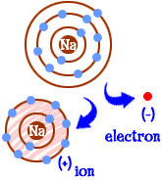
Note: You are expected to work on this packet during the allotted class practice time.
Packet Points
/35 | Completed Class Notes
/35 | Completed Classwork
/5 | Writing Name on Every Page
/25 | Handed Packet in on Time
/ | Homework
/ | Followed Classroom Policies
/ | Classwork Participation
/ | TOTAL POINTS
Name of Chemist:
__________________________________________________________________

Period: ___________
DUE _________________________

*All Class Notes + Questions MUST be finished for HOMEWORK if not done in class.

Unit#6: Ions

Table of Contents

Topic | Pages | Textbook Pages | Supplementary Materials  (Video or Notes)
Lewis Dot Structure of Elements | 3 - 9 | 184
Octet Rule | 10 - 13 | 183
Cations | 10 - 13 | 220
Anions | 14 - 17
Ions Summary | 18

ANNOUNCEMENTS
- When emailing work to me, it is YOUR RESPONSIBILITY to make sure that it was sent. You MUST write In the SUBJECT FIELD:
- TITLE OF THE ASSIGNMENT
          - p3 if you’re in period 3
          - p4 if you’re in period 4
          - p6 if you’re in period 6

Additional Resources:

*Tutoring with Mr. Gutierrez: Meet Mr. Gutierrez in student cafeteria after school or during 9th or 10th period.

Date: _________________
Objectives: SWBAT write the Lewis dot structures of neutral atoms.

Class Notes

REVIEW:
VALENCE ELECTRONS

Valence electrons (also known as _________________________)
- Found in the outermost part (or the highest occupied level) of the atom.
- Participate in chemical reactions and chemical bonding.

Example#1:

An atom with the following electron configuration: 1s²2s²2p⁶ has _______ valence electrons.

Inner shell electrons are found in the innermost parts of an atom. All electrons that are NOT valence are considered to be inner shell electrons.

Example#1:

An atom with the following electron configuration: 1s²2s²2p⁶ has _______ inner shell electrons.

Write the number of valence electrons each element has next to the symbol. The numbers on top are the group numbers.

1 | 2 | 3 - 12 | 13 | 14 | 15 | 16 | 17 | 18
H | Mg | Sc | B | C | N | O | F | Ne
Li | Ca | Ti | Al | Si | P | S | Cl | Ar
Na | Sr | V | Ga | Ge | As | Se | Br | Kr

Show work at the space below.

What pattern did you notice?

LEWIS DOT STRUCTURES

Lewis Dot Structures: _______________________________ diagram representing ________________ _________________ in an atom

Steps | Example
1. | 1.
2. | 2.
3. | 3.

Lewis Dot Structures Sample Questions

- Draw the Lewis Dot Structure of Chlorine.

- Draw the Lewis Dot Structure of Sulfur.

Real world connection – Why should I care?

Summary

In your own words, summarize today’s main points.

Lewis Dot Structures – GUIDED PRACTICE

Draw the Lewis dot structures for the following elements.

- Titanium

- Aluminum

- Bromine

Once you are finished, have Mr. Gutierrez check your work before continuing to the next page.

Date: _________________
Objectives: SWBAT write the Lewis dot structures of neutral atoms.

Class WORK
Class Work (Independent Practice) Directions: Finish as many questions as you can during class. Refer to your notes and ask at least three classmates before asking me for help. If you do not finish these questions in class, you must finish them for homework.

Draw the Lewis dot structures for the following elements.

- Nickel

- Sulfur

- Krypton

- Neon

- Niobium

- Strontium

- Iron

- Paladium

- Iodine

- Barium

- Cesium

- Silicon

Date: _________________
Objectives: 1) SWBAT describe the Octet Rule and explain why ions form. 2) SWBAT write the electron configuration of cations.

Class Notes

The Octet Rule

- The Octet Rule States that atoms tend to _________________, ____________________, or _____________________ electrons so that they have a total of ________ valence electrons.

- Many atoms become _____________ in order to have 8 valence electrons. ________________________ is the process by which ions form.

- An _________ is an ________________ or ____________________________________, that has a ________________ or __________________ charge.

Cation

A _______________ is a ____________________ charged ion. Cations form when _____________________ atoms ________________ electrons.

Examples:

1.

2.

Electron Configuration of Cations

Element | Neutral | Cation | Cation Symbol
K

Ca
Sc

Real world connection – Why should I care?

Summary

In your own words, summarize today’s main points.

Date: _________________
Objectives: 1) SWBAT describe the Octet Rule and explain why ions form. 2) SWBAT write the electron configuration of cations.

Class WORK
Class Work (Independent Practice) Directions: Finish as many questions as you can during class. Refer to your notes and ask at least three classmates before asking me for help. If you do not finish these questions in class, you must finish them for homework.

For the elements listed in the table below, write down the electron configuration of the neutral form of the atom, the electron configuration of the cation form of each atom, and the cation symbol.

Element | Neutral | Cation | Cation Symbol
1. Aluminum
2. Ytrrium
3. Francium
4. Gallium
5. Gallium

Part II.

- What are positively charged ions called?

- Why do certain atoms lose electrons?

- A neutral atom loses 2 electrons.
- Is this a positive or negative ion?
- If this atom now has 10 inner shell electrons, which element is this?
- Write the symbol of the cation form of this element.

- A neutral atom loses 3 electrons.
- Is this a positive or negative ion?
- If this atom now has 2 inner shell electrons, which element is this?
- Write the symbol of the cation form of this element.

- Consider the element Argon. Would a neutral atom of Argon gain or lose electrons? Why or why not? Be sure to mention the Octet Rule in your response.

Date: _________________
Objectives: 1) SWBAT describe the Octet Rule and explain why ions form. 2) SWBAT write the electron configuration of anions.

Class Notes

Quick Review: The Octet Rule

- The Octet Rule States that atoms tend to gain, lose, or share electrons so that they have a total of 8 valence electrons.

- Many atoms become IONS in order to have 8 valence electrons.

- An ION is an atom or group of atoms that has a positive or negative charge.

Anions

A _______________ is a ____________________ charged ion. Cations form when _____________________ atoms ________________ electrons.

Examples:

1.

2.

Electron Configuration of Anions

Element | Neutral | Anion
N

F
S

Summary

In your own words, summarize today’s main points.

Date: _________________
Objectives: 1) SWBAT describe the Octet Rule and explain why ions form. 2) SWBAT write the electron configuration of anions.

Class WORK
Class Work (Independent Practice) Directions: Finish as many questions as you can during class. Refer to your notes and ask at least three classmates before asking me for help. If you do not finish these questions in class, you must finish them for homework.

For the elements listed in the table below, write down the electron configuration of the neutral form of the atom, the electron configuration of the anion form of each atom, and the anion symbol.

Element | Neutral | Anion | Anion Symbol
1. Nitrogen
2. Oxygen
3. Iodine
4. Selenium
5. Astatine

Part II.

- What are negatively charged ions called?

- Why do certain atoms gain electrons?

- A neutral atom gains 2 electrons.
- Is this a positive or negative ion?
- If this atom were Sulfur, how many electrons does it now have in TOTAL?
- Write the symbol of the anion form of this element.

- A neutral atom gains 3 electrons.
- Is this a positive or negative ion?
- If this atom now has 10 inner shell electrons, which element is this?
- Write the symbol of the anion form of this element.

- Explain why Noble Gases do not usually undergo ionization.

Group | 1 | 2 | 3 – 12 (some exceptions apply) | 13 | 14 | 15 | 16 | 17 | 18
Valence
Type of Ion (Charge)

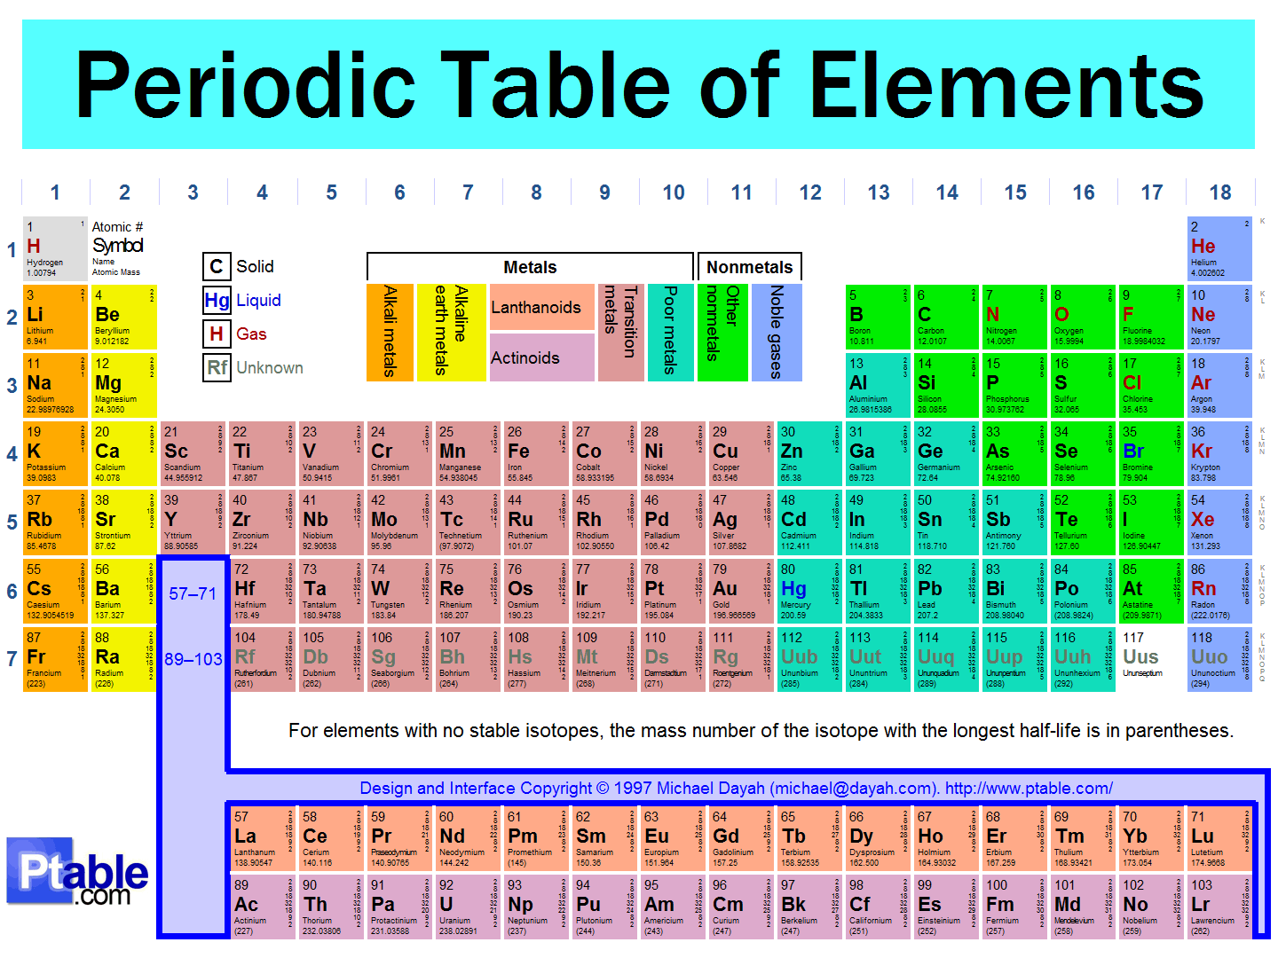

Complete the following table using your notes.
Octet Rule
Ion
Cation
Anion
Make sure Mr. Gutierrez stamps/signs this by the end of the period. You CANNOT get the stamp/signature for a day later on. It is your responsibility to remind Mr. Gutierrez. You will NOT receive a stamp if you did not follow all classroom policies or actively work on the practice problems during the allotted class time. A stamp means you received all 10 points. No stamps means you’ve received zero points. If you completed some work, I may give you partial credit based on my discretion. If you are absent, write the date on the day you were absent and write the word “Absent.” DO NOT LOSE THIS SHEET!!! (If you lose this sheet, you will lose all of your participation points. NO EXCEPTIONS.)

Day of Week | Followed All Classroom Policies (Respectful, on time, prepared, engaged…) | Class work Participation | Homework
Monday | /10 | /10 | /10
Tuesday | /10 | /10 | /10
Wednesday | /10 | /10 | /10
Thursday | /10 | /10 | /10
Friday | /10 | /10 | /10

Classroom Policy Violation Codes

P = Phone
C = Cursing
T = Talking
L = Late to class
O.T. = Off Task
N.iP = Did not bring iPad
Unp = Unprepared

Teacher Comments:

