Environmental Science
Chapter 13:
Mineral Resources and Mining
NOTES

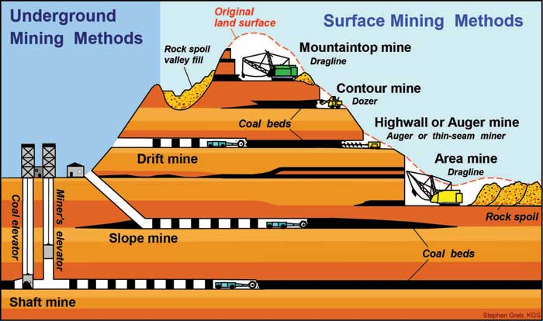

Class Website: http://aofscience.weebly.com

Mr. Gutierrez’s email: gutierrezbr@elizabeth.k12.nj.us
Packet |  | Followed All Classroom Policies
/95 | Completed Class Notes | / | Monday
/5 | Writing Name on Every Page | / | Tuesday
 |  | / | Wednesday
 |  | / | Thursday
 |  | / | Friday
/100 | Total Points | / | Total Points

Name of Environmental Scientist (Your Name):
__________________________________________________________________

Period: ___________

Table of Contents

Topic | Packet Page(s) | Textbook Page
1. Minerals | 3 -4 | 392 – 393
2. Mineral Formation | 5 | 393 – 394
3. Rocks | 6 - 7 | 395 – 397
4. Mining Methods | 8 - 11 | 399 – 402
5. Processing Minerals and Metals | 12 | 403 - 404
6. Impacts of Mining | 13 | 405 – 407

Date: _________________
Objective: SWBAT explain what a mineral is.

MINERALS

A mineral is a naturally occurring, inorganic solid that has an orderly crystalline structure and a definite chemical composition.

A Mineral Must Have the Following Criteria:

1.

2.

3.

4.

5.

SIDE NOTE ON CRYSTALS

_______________________ are solid, geometric forms of minerals produced by a ___________________.

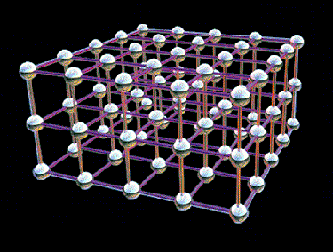

Properties of Minerals

Property | Description
- Color | A few minerals can be identified by their color. But color varies in most minerals depending on how they form.
- Streak | The streak of a mineral is the color of its powder. Although mineral color may vary, streak color does not.
- Luster | How light is reflected off a mineral’s surface is called luster. It may be described as glassy, earthy, silky, metallic, etc.
- Crystal | A mineral can be identified by the particular arrangement of its atoms.
- Hardness | Mohs scale ranks mineral hardness 1–10.  1 = talc, which can be scratched by a fingernail.  10 = diamond, which can scratch all known common minerals.
- Cleavage | A mineral that splits easily along a flat surface and forms a new “face” is said to have cleavage.
- Fracture | Minerals that break irregularly, rather than leaving a flat surface, have fracture, not cleavage.
- Density | Each mineral has a characteristic density—mass per unit volume.

Date: _________________
Objective: SWBAT describe how minerals form.

MINERAL FORMATION

Minerals can form by crystallization from magma or lava, from precipitation related to evaporation of hydrothermal solutions, or from exposure to high pressure and temperature, or they can be produced by organisms.

Ways That Minerals  Can Form | Description
Crystallization from
magma or lava
Precipitation
Pressure and
temperature
Produced by
organisms

Date: _________________
Objective: SWBAT identify types of rocks and the stages of the rock cycle.

ROCKS

Forces deep inside and at the surface of Earth produce changes in rock that cause the same material to cycle between igneous, sedimentary, and metamorphic rock stages.

Igneous Rock | - ______________when _____________cools and hardens  - Can cool inside the earth ______________ OR on its surface from volcanoes _____________________
Metamorphic Rock | - Formed from particles of sand, shells, pebbles, and other fragments (together called ___________________)  - Builds up in __________________and over time hardens into rock  - Only type to ____________________________
Sedimentary Rock | - Formed under surface of the earth from intense __________________ and __________________  - Some have layered or banded appearance while others do not

ROCK CYCLE

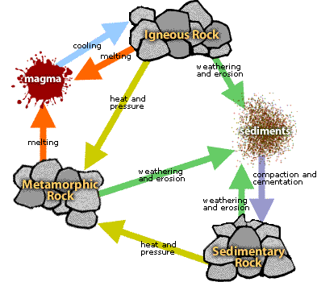

Additional Notes/Summary in Your Own Words:

Date: _________________
Objective: SWBAT describe different methods used for mining.

MINING METHODS

Mining companies seek and gather valuable resources such as metals, nonmetallic minerals, and fuel sources.

Mining companies have developed many techniques to access resources close to the surface of Earth, deep underground, and even underwater.

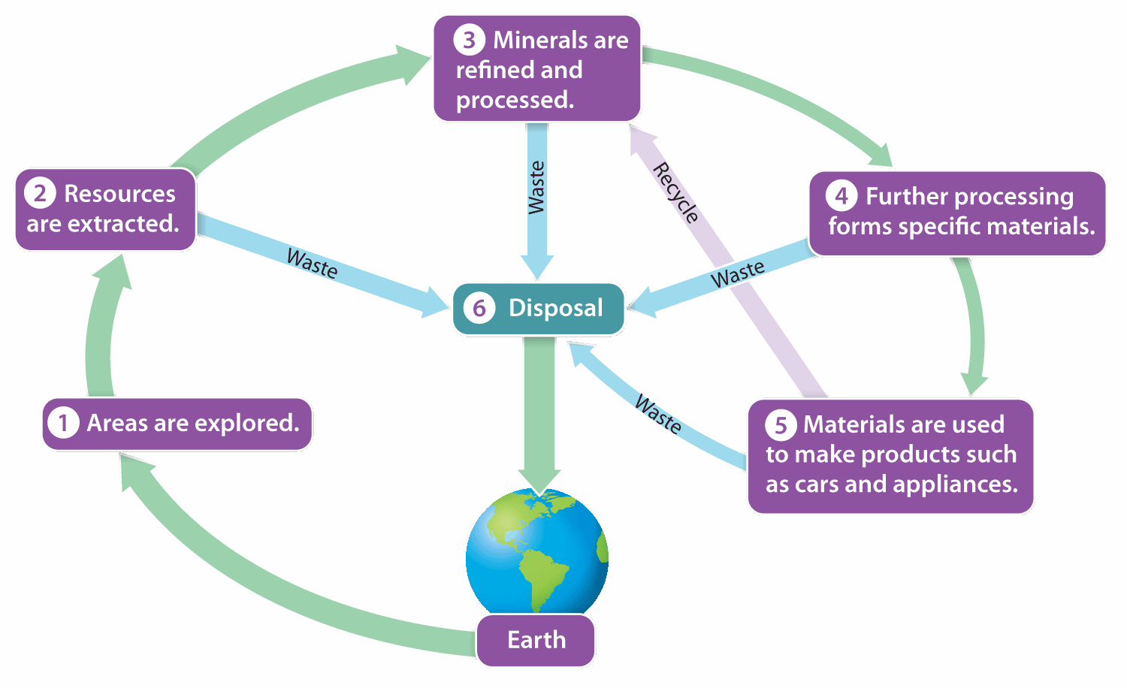

MINING TECHNIQUES

Mining Technique | Description
1. | - _____________ of surface soil and _____________ are removed from large areas to ____________ the resource  - Used to mine coal, sand, and gravel
2. | - Vertical _____________ are dug deep into the _____________, and networks of horizontal tunnels are dug or ________________ to follow deposits of the resource  - Used for metals such as zinc, lead, nickel, tin, gold, copper, and uranium and for nonmetallic minerals such as diamonds, phosphate, and salt.
3. | - When a mineral is ____________________________ and _______________ throughout a rock formation  - Involves digging a _____________________________ and removing the ___________ and unwanted rock that surrounds the ore.
4. | - First, forests are _____________ and the timber is sold and burned.  - Then, the ________________ is removed and rock is _____________ away to expose the resource.
5. *** | - Rather than __________________________ from the ground, miners sometimes pump a _______________________ into a mine to leach the desired resource from the __________  - Once the solution has reacted with the ore, the _______________ is removed from the mine, taking the _____________________ with it.
6. Placer Mining
7. Undersea Mining
***SOLUTION MINING

Label the diagram using sentences from the sentence bank to show how steel is produced and used.

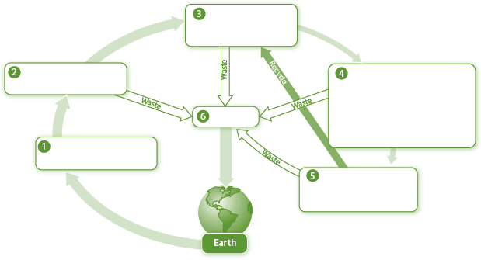

Areas are explored. | Iron ore is smelted to further extract  iron. Mixed with other metals or  chemicals, it is melted and reprocessed  into steel rods and sheets.
Disposal
Steel is used to make appliances and
other products.
Iron ore is removed from the ground. | Iron is separated from the ore.

Additional Notes/Summary in Your Own Words:

Date: _________________
Objective: SWBAT explain how metals are processed.

PROCESSING MINERALS AND METALS

After mining, ores and other extracted materials are processed to separate the desired materials, combine them with other materials, or alter their properties.

Breakdown of Ore
Separation from Ore
Metal Production

Date: _________________
Objective: SWBAT describe the negative impacts of mining on the environment.

NEGATIVE IMPACTS OF MINING

Environmental impacts of mining include erosion, increased sediment and debris, and pollution of water, land, and air. Mining can also have negative impacts on society.

NEGATIVE ENVIRONMENTAL IMPACTS OF MINING

Make sure Mr. Gutierrez stamps/signs this by the end of the period. You CANNOT get the stamp/signature for a day later on. It is your responsibility to remind Mr. Gutierrez. You will NOT receive a stamp if you did not follow all classroom policies or actively work on the practice problems during the allotted class time. A stamp means you received all 10 points. No stamps means you’ve received zero points. If you completed some work, I may give you partial credit based on my discretion. If you are absent, write the date on the day you were absent and write the word “Absent.” DO NOT LOSE THIS SHEET!!! (If you lose this sheet, you will lose all of your participation points. NO EXCEPTIONS.)
Day of Week | Followed All Classroom Policies (Respectful, on time, prepared, engaged…) | Notes  (Took all required notes)
Monday | / | /
Tuesday | / | /
Wednesday | / | /
Thursday | / | /
Friday | / | /
GENERAL COMMENTS

