Environmental Science
Chapter 17:
Nonrenewable Energy

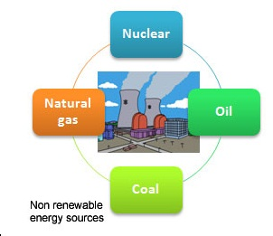
Class Website: http://aofscience.weebly.com

Mr. Gutierrez’s email: gutierrezbr@elizabeth.k12.nj.us

Packet |  | Followed All Classroom Policies
/80 | Completed Class Notes | / | Monday
/20 | Writing Name on Every Page | / | Tuesday
 |  | / | Wednesday
 |  | / | Thursday
 |  | / | Friday
/100 | Total Points | / | Total Points

Name of Environmental Scientist (Your Name):
__________________________________________________________________

Period: ___________
Table of Contents

Topic | Packet Page | Textbook Page
1. Introduction to Energy | 3 – 7 | 516 - 521
2. Fossil Fuel | 8 - 10 | 522 - 528
3. Nuclear Energy | 11- 14 | 536 - 541

Date: _________________
Objective: SWBAT define energy and differentiate between kinetic and potential energy . energy.

ENERGY

Energy, which is the ability to do work, can be classified as either kinetic or potential.

KINETIC | POTENTIAL
Kinetic energy is due to __________________ | Potential energy is due to ___________________________________________________  (stored energy)
Ex: | Ex:

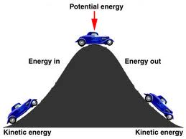

Date: _________________
Objective: SWBAT describe the different forms of energy.

FORMS OF ENERGY
Forms of energy include mechanical energy, electrical energy, thermal energy, electromagnetic energy, chemical energy, and nuclear energy.

- Energy is the ability to do work or cause a change

Form of Energy | Description
1. Mechanical | Associated with the _____________ and _____________ of an object; can be kinetic or potential. Usually involves ________________  Ex:
2. Electrical | Associated with __________________________; can be kinetic  or potential  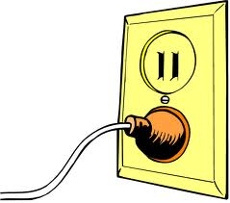  Ex:
3. Thermal | Kinetic energy of atoms and molecules—  the _______________ atoms and molecules move in an object, the _______________it  becomes  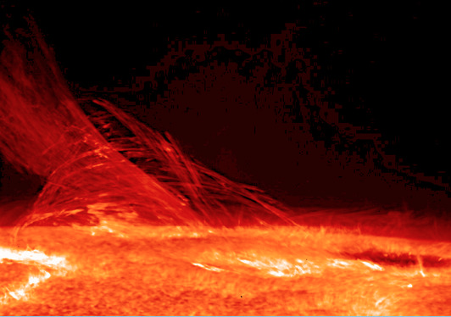  Ex:
4. Electromagnetic | Kinetic energy that travels _______________________________  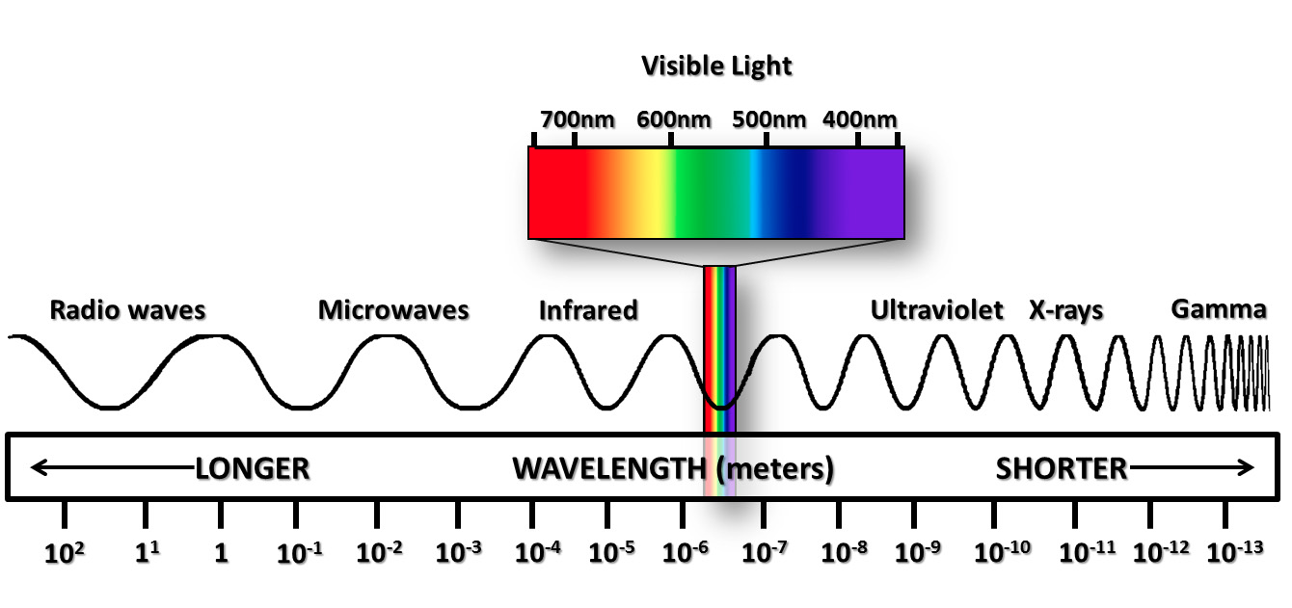  Ex:
5. Chemical | Potential energy stored in _________________________  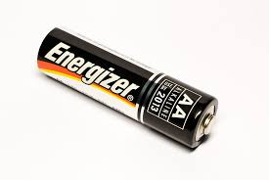  Ex:
6. Nuclear | Potential energy stored by _______________that hold ____________________________________  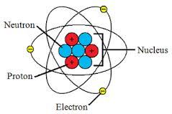

ENERGY CONVERSION

- Energy ___________________________; it can only be ________________, or ___________________, from one form to another.

- Combustion is the process by which a fuel burns because it combines rapidly with oxygen. It converts _________________ to ________________ and ____________________. You feel the thermal energy as heat and see the electromagnetic energy as light.

RENEWABLE VS. NONRENEWABLE

RENEWABLE SOURCE | NONRENEWABLE SOURCE
Nearly ____________________ or ________________________in a relatively ________________;  Includes:  sunlight, wind, flowing water, heat from Earth | ____________________________ in a reasonable time;  Includes: fossil fuels and nuclear energy
ENERGY: Summary of Key Concepts
Energy, which is the ability to do work, can be classified as either kinetic or potential.
Forms of energy include mechanical energy, electrical energy, thermal energy,
electromagnetic energy, chemical energy, and nuclear energy.
Human society uses renewable and nonrenewable energy resources in industry,
transportation, commerce, and residences.

Summary/Personal Notes

Date: _________________
Objective: SWBAT describe how fossil fuels form.

FOSSIL FUELS

Fossil fuels form from the remains of organisms that lived millions of years.

- Fossil fuels include: _______________, ______________, and _______________

- Formed from the _________________________________ over millions of years

- Different conditions produce different fossil fuels

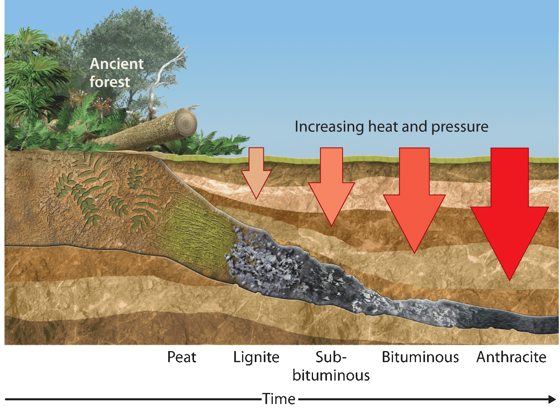

- Coal  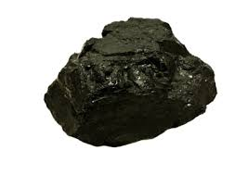 | - Formed from ________________ subjected to high _________ and _______________ over millions of years  - Provides ____________ of the world’s energy  - Relatively cheap, easy to process and transport
- Oil/Petroleum  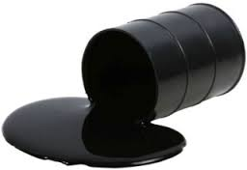 | - _______________________ fossil fuel made up mostly of ______________________  - Formed from the ____________________________ organisms and found in underground ___________  - Used in fuel for ____________, ______________, planes, ships
- Natural Gas | - Natural gas consists of _________________________ mixed in with small amounts of other gases.  - Often found _____________ oil or coal  deposits  - Much ___________________ than coal or oil and releases  _______________________ when combusted  - Used for ___________________, appliances (stoves, dryers), and __________________________  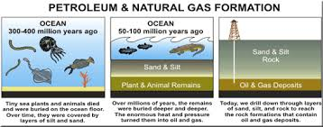

FOSSIL FUEL SUPPLY

- Consumption is still rising, but new fossil fuels do not form on a human timescale.

- New oil sources—oil sands, oil shale, methane hydrates— are expensive, energy-intensive, and can be hazardous to obtain.

- Coal sources are still relatively abundant, but are finite (limited)
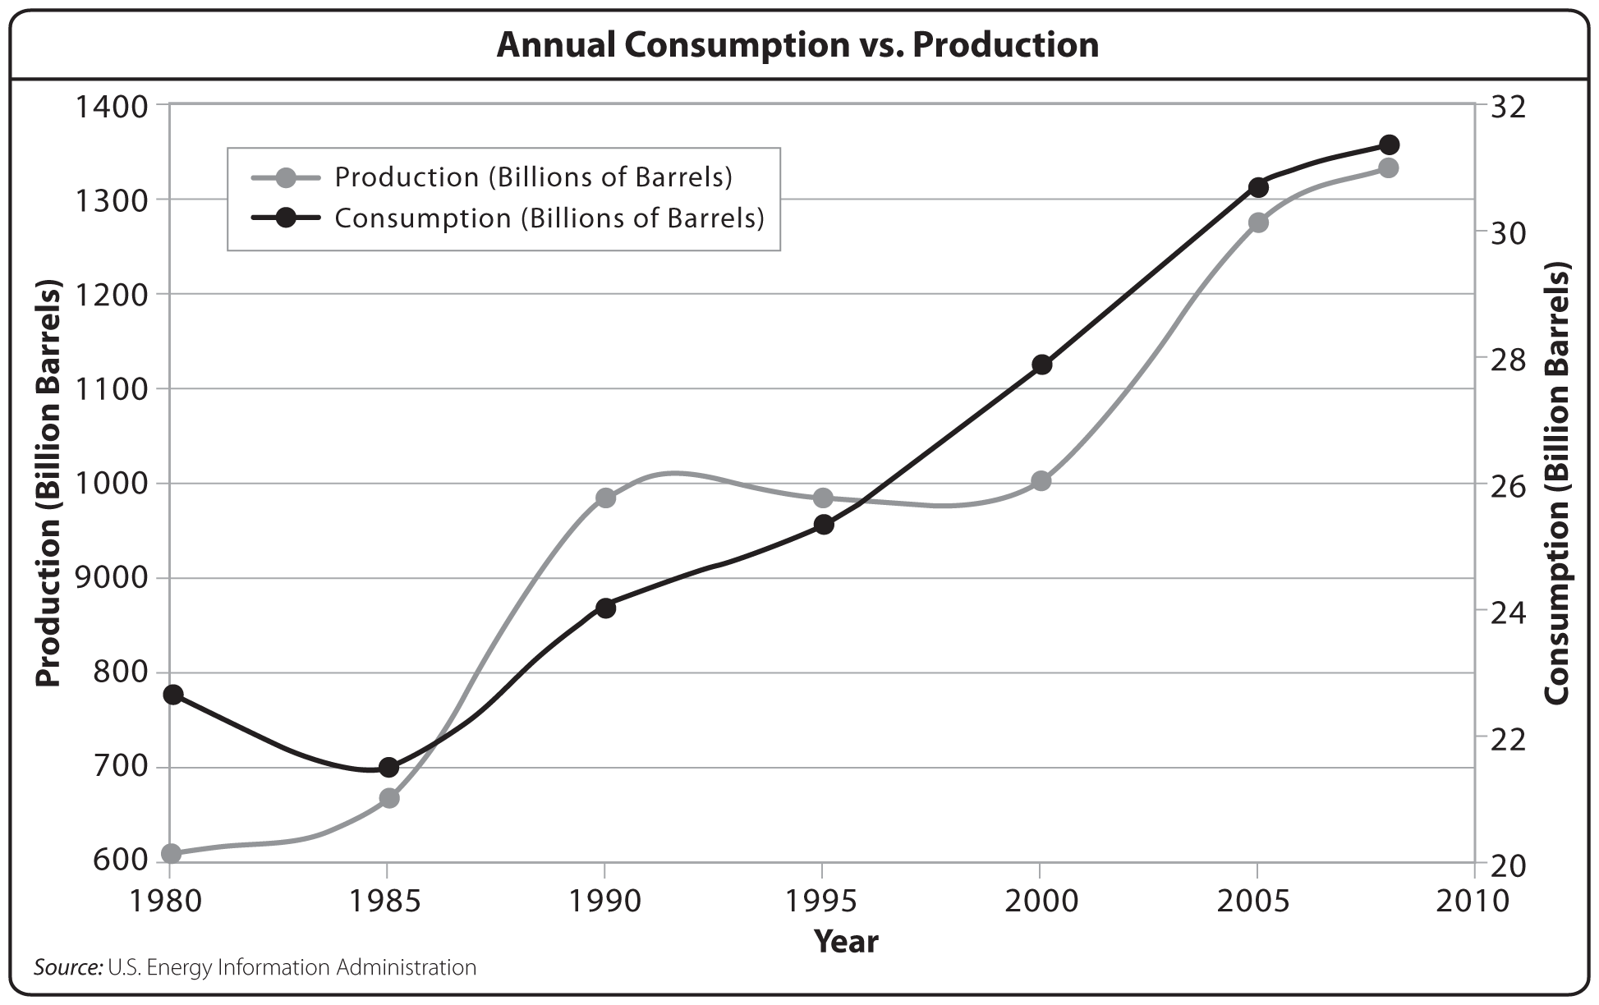

FOSSIL FUELS: Summary of Key Concepts
Fossil fuels formed from the remains of organisms that lived millions of years ago.
Coal, which is used mainly to generate electricity, is obtained by mining.
Petroleum, which is obtained by drilling, is a major source of energy and is used to
make a variety of products.
Natural gas yields a large amount of energy and is less polluting than other fossil fuels.
The supply of fossil fuels is limited.

Date: _________________
Objective: SWBAT differentiate between nuclear fusion with nuclear fission.

NUCLEAR ENERGY

The process of nuclear fission releases energy.

The Atom

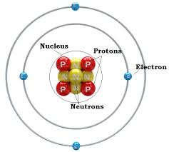

NUCLEAR FISSION

- _____________ an atomic nucleus into____________________________

- Releases neutrons and large ____________________________. If enough unstable nuclei are present, a nuclear chain reaction can occur.

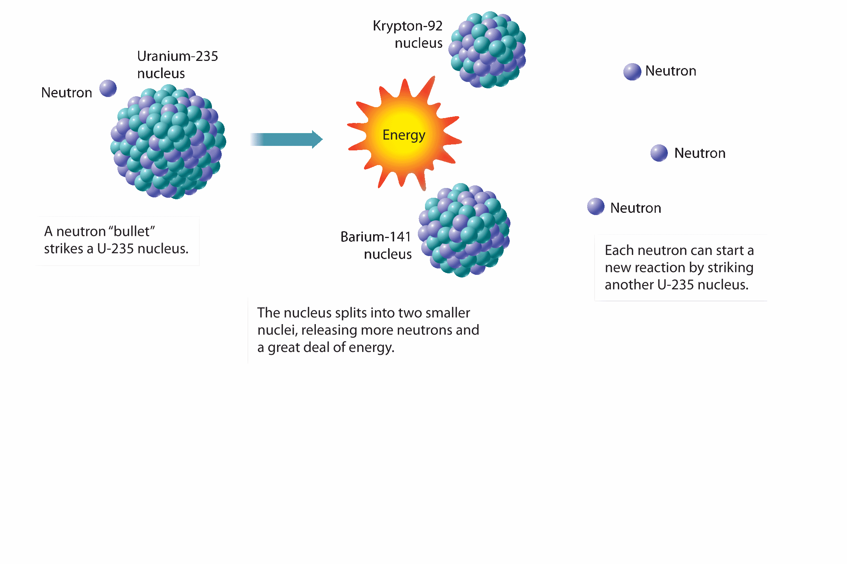
PROS | CONS
- ____________alternative energy source  - Creates lots of energy  - Used for nuclear bombs | - Used for nuclear bombs  - Can cause __________________  - Reactor accidents are dangerous  - ____________________ (Uranium and Plutonium)

NUCLEAR FUSION

- _________________________ atomic nuclei to form ____________________

- Releases much _____________________ than fission

- Currently impractical because ______________________________________________________________, but scientists continue exploring fusion for our future energy needs

PROS | CONS
- Creates even more energy  - Lots of fuel supply (Hydrogen)  - ______________________________  - No risk of __________________ | - Used for Hydrogen bombs (8x more powerful than atomic bombs)  - Technology for clean energy hasn’t been developed yet  - It will _____________________________

Date: _________________
Objective: SWBAT Describe how a nuclear power plant generates electricity.

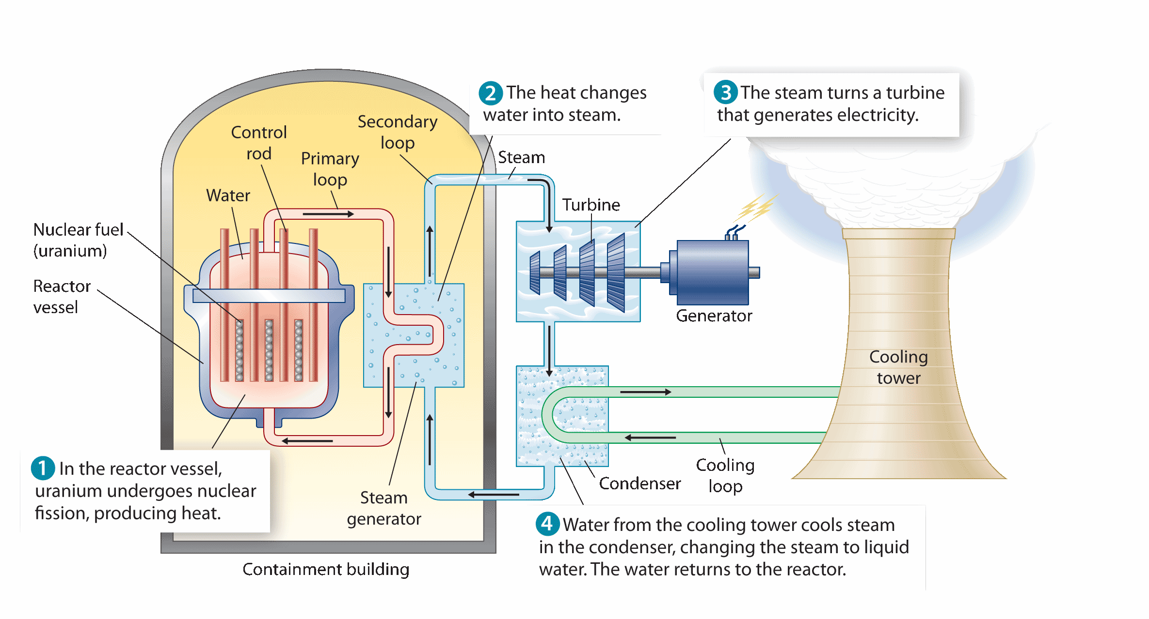

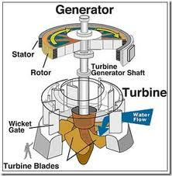

Date: _________________
Objective: Explain the advantages and disadvantages of nuclear power.

Benefits and Costs of
Nuclear Power

BENEFITS (Advantages) | COSTS (Disadvantages)
Under normal conditions, nuclear power plants are _________for workers than coal-burning power plants. | Nuclear waste must be ______________________

NUCLEAR ENERGY: Summary of Key Concepts
The process of nuclear fission releases energy.
In a nuclear power plant, nuclear fission is used to generate electricity.
Nuclear power does not create air pollution, but its problems include risk of accidents
and disposal of wastes.
Nuclear fusion has advantages over fission, but the technology does not yet exist to use
fusion to generate power.

Make sure Mr. Gutierrez stamps/signs this by the end of the period. You CANNOT get the stamp/signature for a day later on. It is your responsibility to remind Mr. Gutierrez. You will NOT receive a stamp if you did not follow all classroom policies or actively work on the practice problems during the allotted class time. A stamp means you received all 10 points. No stamps means you’ve received zero points. If you completed some work, I may give you partial credit based on my discretion. If you are absent, write the date on the day you were absent and write the word “Absent.” DO NOT LOSE THIS SHEET!!! (If you lose this sheet, you will lose all of your participation points. NO EXCEPTIONS.)
Day of Week | Followed All Classroom Policies (Respectful, on time, prepared, engaged…) | Class work Participation | Homework
Monday | /10 | /10 | /10
Tuesday | /10 | /10 | /10
Wednesday | /10 | /10 | /10
Thursday | /10 | /10 | /10
Friday | /10 | /10 | /10

