**Chemistry**

**YOUR CHOICES + YOUR ACTIONS = YOUR FUTURE!!!**

**Packet# 2**

**Unit#2: Matter and Changes**

(BRING THIS WITH YOU TO EVERY CLASS)

*“Success is not the result of spontaneous combustion. You must set yourself on fire.”*

***Edmodo Group Code:*** *ozm60q* (http://www.edmodo.com)

***Class Website:*** http://mrgchem.weebly.com

***Mr. Gutierrez’s email:*** gutierrezbr@elizabeth.k12.nj.us

Text Messaging Reminders: Text @aofchem to 23559

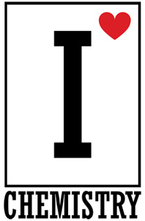

*Note: You are expected to work on this packet during the allotted class practice time.*

|  |  |  |  |  |
| --- | --- | --- | --- | --- |
| **Packet** | | **Followed All Classroom Policies** | | **Class work Participation** |
| /35 | Completed Class Notes | / | Monday | / |
| /35 | Completed Classwork | / | Tuesday | / |
| /5 | Writing Name on Every Page | / | Wednesday | / |
| /25 | Handed Packet in on Time | / | Thursday | / |
| /100 | Total Points | / | Friday | / |
|  |  | / | Total Points | / |

Name of Chemist:

________________________________________________________________________

Period: ___________

*\*All Classnotes + Questions MUST be finished for HOMEWORK if not done in class.*

***DUE _________________________***

**Unit#2: Matter and Change**

***Table of Contents***

|  |  |  |  |
| --- | --- | --- | --- |
| **Topic** | **Pages** | **Textbook Pages** | **Khan Academy/**  **YouTube Topic** |
| 2. Chemical and Physical Properties and Changes |  | 6 – 7, 9 |  |
| 3. States of Matter |  | 7 - 8 |  |
| 4. Classification of Matter |  | 11 - 14 |  |
| 5. The Periodic Table |  | 16 – 17 |  |
| 6. Metals, Nonmetals, and Metalloids |  | 18 – 20 |  |

**Additional Resources:**

**\*Tutoring with Mr. Gutierrez:** Meet Mr. Gutierrez in student cafeteria after school or during 10th period.

|  |
| --- |
| **Date: _________________**  **Objectives: 1) SWBAT distinguish between physical or chemical property. 2) SWBAT classify changes as either physical or chemical.** |
|  |

Class Notes:

**Matter and Its Properties**

What is matter? ­­­­­­­­____________________________________________________________________________

An *element* is a ______________________ that cannot be broken down into simpler, stable substances and is made of only ________ type of atom.

The smallest unit of an element is an _______________.

|  |  |  |
| --- | --- | --- |
|  | *Physical Property* | *Chemical Property* |
| Definition |  |  |
| Examples | * ________________________ * ________________________ * ________________________ | * ________________________ * ________________________ * ________________________ |
|  | *Physical Changes* | *Chemical Changes* |
| Definition |  |  |
| Examples | * ________________________ * ________________________ * ________________________ | * ________________________ * ________________________ * ________________________ |

|  |
| --- |
| **Date: _________________**  **Objectives: 1) SWBAT distinguish between physical or chemical property. 2) SWBAT classify changes as either physical or chemical.** |
|  |

***Class Work (Independent Practice):*** Finish as many questions as you can during class. Refer to your notes and ask at least three classmates before asking me for help. If you do not finish these questions in class, you must finish them for homework.

1. *Fill in the blank.* A **physical property** is a characteristic that can be _________________ or __________________without changing the ________________ of the substance.
2. Examples of physical properties include:

* _________________________
* _________________________

1. Which of the following are examples of physical change?
2. Cutting
3. Melting
4. Grinding
5. Boiling
6. All of the above
7. *Fill in the blank.* A **chemical property** is a characteristic that relates to a substance’s ability to __________________.
8. Provide one example of a chemical change.

*Directions: Label each property as either chemical or physical.*

1. The color of the ball is red.
2. Iron reacts with oxygen and forms rust.
3. The boiling point of water is 100 degrees Celsius.
4. Baking soda reacts with vinegar.
5. The gas is flammable.
6. Oxygen is a gas.
7. Argon is not very reactive.
8. Nitrogen is a colorless gas.
9. The silver spoons tarnished and turned dark.
10. The piece of metal is magnetic.
11. Gold is nonflammable.
12. Oxygen is odorless and colorless.
13. Copper turns green when exposed to the environment.
14. The piece of metal is magnetic.
15. The density of water is 1.0 gram per cubic centimeter.
16. Diamonds are a very hard substance.
17. The Tree is 8 meters high.
18. Sodium reacts very easily with other elements.
19. Copper conducts electricity.
20. Diamonds are a very hard substance.
21. Classify the following examples as either a physical or chemical change and provide a reason in the spaces below.

|  |  |  |
| --- | --- | --- |
| ***Example*** | ***Physical or Chemical Change? (Choose one)*** | ***Reason*** |
| Digestion of food |  |  |
| Baking a cake |  |  |
| Tearing a piece of paper |  |  |
| Melting of ice |  |  |
| Rusting of iron |  |  |
| Burning of fuel |  |  |
| Boiling of water |  |  |
| Dissolving sugar into water |  |  |
| Freezing of water |  |  |
| Alka-seltzer gives off carbon dioxide |  |  |
| Milk goes sour (expires) |  |  |

|  |
| --- |
|  |
| a. |
| b. |
| c. |
| d. |

|  |
| --- |
| **Date: _________________**  **Objective: SWBAT explain the differences between the solid, liquid, and gas states.** |
|  |

Class Notes:

**States of Matter**

Review: A physical change is a change that does not change the identity of the substance.

In order for a *phase change* to occur, ______________ must be added or removed.

|  |  |  |  |  |
| --- | --- | --- | --- | --- |
|  | ***Solid*** | ***Liquid*** | ***Gas*** | ***Plasma*** |
| *Arrangement of Particles* |  |  |  |  |
| *Description* | * Has a definite ______________ and ______________ * Particles are held together by ______________ attractive forces * Vibrate about ____________ points | * Has a definite ___________ but indefinite ___________ * Takes the shape of its _____________ * Particles can __________ __________ each other | * Does NOT have a definite ____________ or _________ * Move very rapidly * Particles are _________   _________ ____________ |  |

*Phase Change Processes*

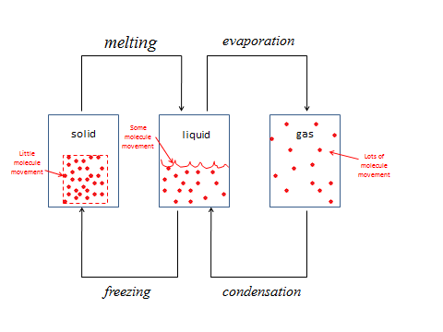

|  |
| --- |
| **Date: _________________**  **Objective: SWBAT explain the difference between the solid, liquid, and gas states.** |
|  |

***Class Work (Independent Practice):*** Finish as many questions as you can during class. Refer to your notes and ask at least three classmates before asking me for help. If you do not finish these questions in class, you must finish them for homework.

1. List 2 examples found in your home for each of the following:
   1. SOLID-
   2. LIQUID-
   3. GAS-
2. Which description best describes a liquid?
   1. It has a definite shape and volume.
   2. It has a definite volume but no definite shape.
   3. It expands to fill the shape and volume of its container.
   4. It cannot flow.
3. Describe one difference between how particles are arranged in a solid and how they are arranged in a gas.
4. Determine if heat is **ADDED** or **REMOVED** in each of the following phase changes:
   1. Melting-
   2. Evaporation-
5. Consider the following statements:
   * + 1. In solids, the particles are very far apart.
       2. In liquids, the particles can slide past each other.
       3. Gases have neither a definite shape or volume.
   1. Only I is true.
   2. Only I and II are true.
   3. Only II and III are true.
   4. I, II, and III are true.
6. What happens to the movement of particles when the temperature changes from 25 **°** F to 100 **°** F?
   1. It stays the same
   2. They move faster
   3. They move slower
   4. They exchange places
7. Which of the following substances does NOT take the shape of its container?
   * + - 1. Coke
         2. Cooking oil
         3. A ruler
8. Complete the following diagram by writing the appropriate phase change process.

9. In the space below, write a summary of everything you learned today.

|  |
| --- |
|  |

|  |
| --- |
| **Date: _________________**  **Objectives: 1) SWBAT distinguish between a mixture and a pure substance. 2) SWBAT identify methods of separation of mixtures.** |
|  |

**Classification of Matter**

There are two main types of matter: ________________________ and ____________________________.

If it can be physically separated by the following methods:

* ________________________
* ________________________
* ________________________

Then it is a **mixture**. A ***mixture*** is a blend of ___________ or more kinds of matter, each retaining its ______________ and _______________. The two types of mixtures are:

1. *Heterogenous Mixture*: ________________________________________________________
2. *Homogenous Mixture:* _________________________________________________________. Homogenous mixtures are also called ___________________.

If it CANNOT be physically separated by the methods mentioned above, then it is a **pure substance*.*** A *pure substance* is a substance that is made up of only one component. Every sample of a given pure substance has the same _______________________. There are two types of pure substances:

1. *Compounds*: ________________________________________________________
2. *Elements:* ________________________________________________________



**CAUTION**: Do not confuse a homogenous mixture and a pure substance. Remember a homogenous mixture can be *physically separated* whereas a pure substance cannot!

|  |
| --- |
| **Date: _________________**  **Objectives: 1) SWBAT distinguish between a mixture and a pure substance. 2) SWBAT identify methods of separation of mixtures.** |
|  |

***Class Work (Independent Practice):*** Finish as many questions as you can during class. Refer to your notes and ask at least three classmates before asking me for help. If you do not finish these questions in class, you must finish them for homework.

1. Fill out the chart below describing the differences between a mixture and pure substance.

|  |  |  |
| --- | --- | --- |
| **Homogenous Mixture** | **Heterogenous Mixture** | **Pure Substance** |
|  |  |  |

1. If a substance cannot be physically separated, it is considered a _____________________________ (choose one: pure substance or mixture).
2. Mary notices that the top part of the liquid she’s analyzing is different than the bottom part. Based on her observations, she can conclude that the liquid is a __________________________________ (choose one: pure substance, heterogenous mixture, or homogenous mixture).

*Use the diagram below to answer questions 11 and 12.*



1. What type of mixture is represented by X? (1pt)
2. What type of substance is represented by Z? (1pt)
3. Classify the following as a pure substance, homogenous mixture, or heterogenous mixture.
   1. Coffee ________________
   2. Sugar _____________
   3. Water ________________
   4. Magnesium _______________
   5. A bag of jelly beans _____________
   6. A pepperoni pizza _______________
   7. Rocks in sand ___________________
   8. Oxygen _____________________
   9. Cesar salad ____________________
   10. Pepper dissolved in water ____________________
   11. Unfiltered air _______________________
   12. An orange _______________________
   13. Aluminum _______________________
   14. Rusted steel _______________________
   15. A Dunkin Donuts coffee coolatta ______________________
   16. Coca Cola_______________________
   17. Butter pecan ice cream _______________________
4. Andrew has a mixture of alcohol and water inside a beaker. What is the best way to separate this mixture?

a.Filtering

b.Using a funnel

c. Boiling

5. How would you separate water and sand?

6. In your own words, describe how you can determine whether or not a substance is a homogenous mixture, heterogenous mixture, or pure substance.

1. Classify each of the pictures below by placing the correct label in the blanks below.

A= Element

B= Compound

C= Mixture of elements

D= Mixture of compounds

E= Mixture of elements and compounds

Each circle represents an atom and each different color represents a different kind of atom. If two atoms are touching then they are bonded together.



|  |
| --- |
| **Date: _________________**  **Objectives: 1) SWBAT use a periodic table to name elements and write their symbols 2) SWBAT describe the arrangement of the periodic table.** |
|  |

**The Periodic Table**

An *element* is ______________________________________________________________________________________________________.

All known elements are arranged in the ­­­­­­­­­­­­­­______________________________.

* Elements are arranged based on their ________________________ properties.
* Similar elements were ______________________ in the Periodic Table.

Each square on the periodic table contains the following information:

1. ________________ (tells you the number of protons)
2. ________________ (most are related to their English names, but some are related to their Latin or German names)
3. ________________

|  |
| --- |
|  |

The ________________ rows are called the ________________.

The ________________ columns are called the _____________.

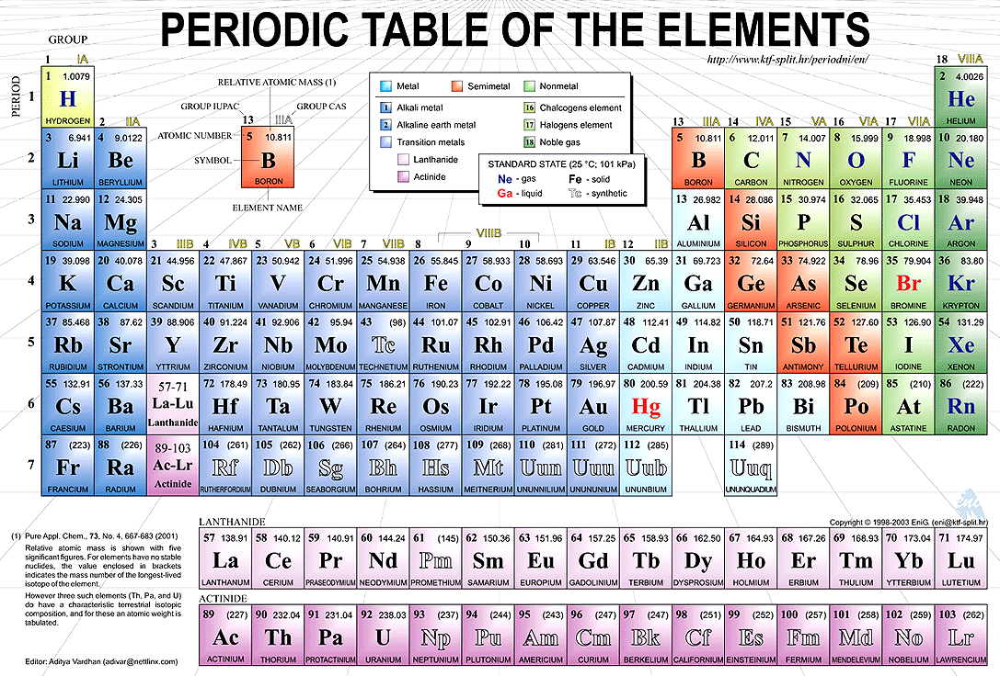

|  |
| --- |
| **Date: _________________**  **Objectives: 1) SWBAT use a periodic table to name elements and write their symbols 2) SWBAT describe the arrangement of the periodic table.** |
|  |

**The Periodic Table**

***Class Work (Independent Practice):*** Finish as many questions as you can during class. Refer to your notes and ask at least three classmates before asking me for help. If you do not finish these questions in class, you must finish them for homework.

1. The periods in the periodic table are the _________________ (vertical columns or horizontal rows).
2. The groups in the periodic table are the _________________ (vertical columns or horizontal rows).
3. Each square on the periodic table contains the following information:

* ________________
* ________________
* ________________

1. Determine the name and symbol of the element in the following locations:
2. Period 3, Group 5 ______ (symbol), __________________ (name)
3. Period 2, Group 2 ______ (symbol), __________________ (name)
4. Period 3, Group 18 ______ (symbol), __________________ (name)
5. Period 5, Group 14 ______ (symbol), __________________ (name)
6. Period 7, Group 8 ______ (symbol), __________________ (name)
7. Why do lithium and potassium react to water in a similar fashion?
8. Which of the following elements is most similar to Bromine?
9. Be
10. Ca
11. Ag
12. At
13. Which of the following elements is most similar to Magnesium?
14. F
15. He
16. Ca
17. V
18. What are some elements that you come into contact with on a regular basis?

|  |
| --- |
| **Date: _________________**  **Objectives: SWBAT list the characteristics that distinguish metals, nonmetals, and metalloids.** |
|  |

**Nonmetals, Metals, and Metalloids**

|  |  |  |
| --- | --- | --- |
| **Metals** | **Nonmetals** | **Metalloids** |
|  |  |  |
|  |  |  |



* Group 1 Elements are called: _______________
* Group 2 Elements are called: _______________
* Groups 3 – 12 Elements are called: ___________
* Group 18 Elements are called: ___________

|  |
| --- |
| **Date: _________________**  **Objectives: SWBAT list the characteristics that distinguish metals, nonmetals, and metalloids.** |
|  |

***Class Work (Independent Practice):*** Finish as many questions as you can during class. Refer to your notes and ask at least three classmates before asking me for help. If you do not finish these questions in class, you must finish them for homework.

**Nonmetals, Metals, and Metalloids**

1. All metalloids are _________ (solid, liquid, gas) at room temperature and have characteristics of both ____________ and ________________.
2. Name two metalloids that you can find from the periodic table.
3. MOST (not all) metals are _____________ (solid, liquid, gas) at room temperature.
4. Write three examples of a metal from the periodic table.
5. *True or false.* All metals have the same properties.
6. *True or false.* Malleability is the ability to be hammered or rolled into thin sheets.
7. Write three examples of a nonmetal from the periodic table.
8. Nonmetal solids tend to be ___________ rather than ______________.
9. Ridiculous; awesome
10. Brittle; malleable and ductile
11. Malleable and ductile; brittle
12. Copper has a metallic luster and can readily be drawn into wire. It is also used in electrical wire. You can conclude that copper is a _____________. (choose one: nonmetal, metalloid, or metal)
13. Luis is stuck in the woods and cannot find his way out. He managed to kill a wild bird, but now wants to cook it. Luckily, he already has some wood that he found and a lighter in his pocket. While he was searching for more tools, he found a plate made of titanium, a plate made of carbon, and a plate made of silicon. If he wants to COOK the dead bird well, which plate should he use? Why?

Make sure Mr. Gutierrez stamps/signs this by the end of the period. You CANNOT get the stamp/signature for a day later on. It is your responsibility to remind Mr. Gutierrez. You will NOT receive a stamp if you did not follow all classroom policies or actively work on the practice problems during the allotted class time.A stamp means you received all 10 points. No stamps means you’ve received zero points. If you completed some work, I may give you partial credit based on my discretion. ***If you are absent, write the date on the day you were absent and write the word “Absent.” DO NOT LOSE THIS SHEET!!!*** (If you lose this sheet, you will lose all of your participation points. NO EXCEPTIONS.)

|  |  |  |  |
| --- | --- | --- | --- |
| **Day of Week** | **Followed All Classroom Policies** (Respectful, on time, prepared, engaged…) | **Class work Participation** | **Homework** |
| *Monday* | /10 | /10 | /10 |
| *Tuesday* | /10 | /10 | /10 |
| *Wednesday* | /10 | /10 | /10 |
| *Thursday* | /10 | /10 | /10 |
| *Friday* | /10 | /10 | /10 |

**Teacher Comments:**