**Chemistry**

*“I can accept failure, everyone fails at something. But I can’t accept not trying.” – Michael Jordan*

**Packet#8**

***Covalent and Ionic Compounds Review***

***Polyatomic Ions***

***Edmodo Group Code:*** *ozm60q* (http://www.edmodo.com)

***Class Website:*** http://mrgchem.weebly.com

***Mr. Gutierrez’s email:*** gutierrezbr@elizabeth.k12.nj.us

Text Messaging Reminders: Text @aofchem to 23559

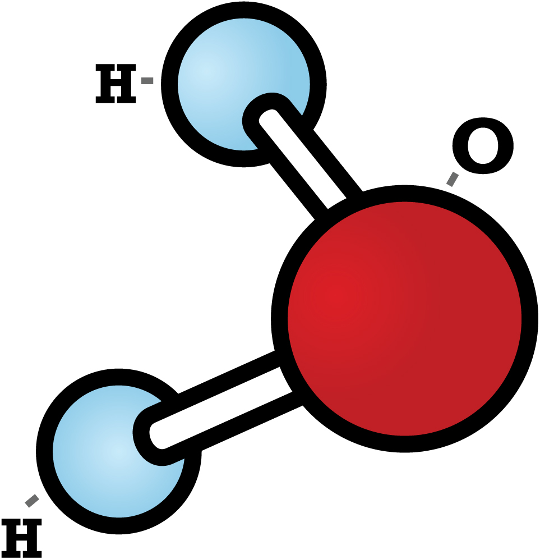

*Note: You are expected to work on this packet during the allotted class practice time.*

|  |  |
| --- | --- |
| **Packet Points** | |
| /35 | Completed Class Notes |
| /35 | Completed Classwork |
| /5 | **Writing Name on Every Page** |
| /25 | Handed Packet in on Time |
| / | Homework |
| / | Followed Classroom Policies |
| / | Classwork Participation |
| / | TOTAL POINTS |

Name of Chemist:

__________________________________________________________________

Period: ___________

***DUE _________________________***

*All Class Notes + Questions MUST be finished for HOMEWORK if not done in class.

***Polyatomic Ions***

***Covalent and Ionic Compounds Review***

***Table of Contents***

|  |  |  |  |
| --- | --- | --- | --- |
| **Topic** | **Pages** | **Textbook Pages** | **Supplementary Materials**  **(Video or Notes)** |
| Polyatomic Ions | 3 - 11 | 226 |  |
| Ionic vs. Covalent Compounds  Review | 12 -17 |  |  |

|  |
| --- |
| **Date: _________________**  **Objectives: 1) SWBAT write the chemical formula and the names of compounds with polyatomic ions.** |

|  |
| --- |
| **Class Notes** |
| **Polyatomic Ions**  **Polyatomic ions** are __________________________________________________________________.  (“Poly-“ means ___________________)  **Oxyanions** are polyatomic ions with oxygen.    **How to Write a Chemical Formula Given the Name of a Polyatomic Ion**  Example#1: Potassium Phosphate   |  |  | | --- | --- | | STEPS | EXAMPLE | | 1. Write the cation symbol first with its correct charge. (Look at your periodic table.) |  | | 2. Write the polyatomic ion in parentheses with the charge outside. (Refer to chart above.) Treat the polyatomic ion as ONE UNIT. |  | | 3. Ignore the plus and minus. Swap the charge numbers and make those your subscripts. |  | | 4. Remove the parentheses if the subscript is one (1). |  | | FINAL ANSWER |  |   **WARNING!!!! WARNING!!! Do not confuse:**   * phosphide (P3-) with phosphate (PO43-) * sulfide (S2-) with sulfate * nitride (N3-) with nitrate   EXAMPLE#2: Magnesium nitrate  EXAMPLE#3: Copper (II) chromate  EXAMPLE#4: Calcium phosphate  **How to Write the Name of Compound with Polyatomic Ions Given the Chemical Formula**  Example#1: K2SO4   |  |  | | --- | --- | | STEPS | EXAMPLE | | 1. Write the name of the cation. |  | | 2. If the chemical formula contains **MORE THAN TWO** types of elements, it most likely has a polyatomic ion. If a polyatomic ion is present, look at your given chart and look for the name that matches with the polyatomic ion. |  | | 3. Write the name of polyatomic ion after the name of the cation. |  | | FINAL ANSWER |  |   **WARNING!!!! WARNING!!! Do not confuse:**   * phosphide (P3-) with phosphate (PO43-) * sulfide (S2-) with sulfate * nitride (N3-) with nitrate   EXAMPLE#2: Na3PO4  EXAMPLE#3: KCH3COO  EXAMPLE#4: Mg(ClO3)2  **Once you are finished, have Mr. Gutierrez check your work before continuing to the next question.** |

|  |
| --- |
| **Date: _________________**  **Objectives: 1) SWBAT write the chemical formula and the names of compounds with polyatomic ions.** |

|  |
| --- |
| **Class WORK**  ***Class Work (Independent Practice*) Directions*:*** Finish as many questions as you can during class. Refer to your notes and ask at least three classmates before asking me for help. If you do not finish these questions in class, you must finish them for homework. |
| Part A.  Directions: Write the **CHEMICAL FORMULA** of the following compounds given its name.   1. sodium acetate 2. potassium permanganate   3. magnesium bromate  4. lithium nitrate  5. calcium nitrite  6. lithium perchlorate  7. sodium phosphate  8. potassium dichromate  9. calcium carbonate  10. potassium acetate  11. sodium sulfate  12. Potassium bicarbonate  Part A.  Part B.  *Directions:* Write the **NAME** of the following compounds given its chemical formula.   1. NaHCO3 2. Na2CO3 3. CuSO4 4. Mg(OH)2 5. Ba(NO3)2 6. Li2SO4 7. MgCl2 8. AgNO3 9. Al2(SO4)3 10. Ca(OH)2 11. CaSO4 12. Hg(NO3)2 13. Pb(NO3)4 |

|  |
| --- |
| **Date: _________________**  **Objective: SWBAT compare and contrast the properties of covalent and ionic bonds.** |

**Ionic vs. Covalent Compounds**

|  |  |  |
| --- | --- | --- |
| PROPERTY | **Ionic Compound** | **Covalent Compound** |
| BONDING |  |  |
| MELTING POINT |  |  |
| BOILING POINT |  |  |
| ELECTRICAL CONDUCTIVITY |  |  |
| Metals, Nonmetals, or Metalloids |  |  |
| OTHER |  |  |

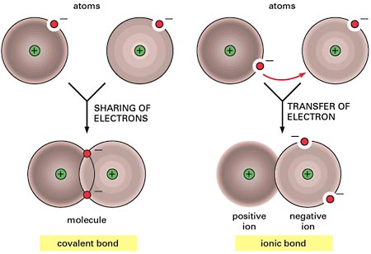

**NAMING: IONIC vs. COVALENT**

**Does the compound have a metal?**

Ionic

**DO NOT** Use Prefixes

Covalent

USE PREFIXES

OTHER NOTES:

|  |
| --- |
| **Class WORK**  ***Class Work (Independent Practice*) Directions*:*** Finish as many questions as you can during class. Refer to your notes and ask at least three classmates before asking me for help. If you do not finish these questions in class, you must finish them for homework. |
| 1. Compound X has a boiling point of 1000 °C and Compound Y has a boiling point of 978 °C. Considering the boiling points of these two compounds, which compound is most likely to be a covalent compound? Explain your answer. 2. Which of the following statements is true? 3. NaCl has a higher electrical conductivity than PBr3 4. NaCl has a lower electrical conductivity than PBr3 5. NaCl has the same electrical conductivity as CO2 6. NaCl has the same electrical conductivity as dinitrogen pentoxide 7. Consider the following table.  |  |  |  | | --- | --- | --- | | **Property** | Compound A | Compound B | | **Boiling Point** | 675 °C | 769 °C | | **Melting Point** | 498 °C | 576 °C | | **Other Properties** | Brittle | Hard |     Based on the information given above, which compound is most likely an ionic compound? Which compound is most likely a covalent compound? Explain your answer.   1. Name two ionic compounds. 2. Which of the following compounds is named incorrectly? 3. K2O, potassium dioxide c. NaOH, sodium hydroxide 4. CaCl­2, calcium chloride d. N­4O8, tetranitrogen octoxide 5. Which of the following compounds would most likely have high electrical conductivity? 6. disilicon hexabromide c. Potassium Chloride 7. N­2O4 d. PCl3   Explain your answer.   1. Name the following compounds. Remember that prefixes are only used for covalent compounds. Use your chart for any polyatomic ions.  * KCl * K2O * SiF4 * CO3 * Ca(OH)2 * Na­3PO4 * As­2O4  1. Write the chemical formula: 2. rubidium oxide 3. dicarbon dioxide 4. Draw the Lewis dot structures of the following compounds: 5. phosphorus trichloride 6. CO2 7. P2 8. Draw the Lewis dot structure of O3. 9. Is there more than one way of answering number 10? If so, what could be the other answer? 10. How many sigma bonds are there in carbon dioxide? 11. Explain the difference between a polar covalent bond and non-polar covalent bond. 12. Ionization energy is the amount of energy required to remove a valence electron in an atom. Consider the Octet Rule and explain why the first ionization energy of fluorine is much higher than that of calcium? |

Make sure Mr. Gutierrez stamps/signs this by the end of the period. You CANNOT get the stamp/signature for a day later on. It is your responsibility to remind Mr. Gutierrez. You will NOT receive a stamp if you did not follow all classroom policies or actively work on the practice problems during the allotted class time.A stamp means you received all 10 points. No stamps means you’ve received zero points. If you completed some work, I may give you partial credit based on my discretion. ***If you are absent, write the date on the day you were absent and write the word “Absent.” DO NOT LOSE THIS SHEET!!!*** (If you lose this sheet, you will lose all of your participation points. NO EXCEPTIONS.)

|  |  |  |  |
| --- | --- | --- | --- |
| **Day of Week** | **Followed All Classroom Policies** (Respectful, on time, prepared, engaged…) | **Class work Participation** | **Homework** |
| *Monday* | /10 | /10 | /10 |
| *Tuesday* | /10 | /10 | /10 |
| *Wednesday* | /10 | /10 | /10 |
| *Thursday* | /10 | /10 | /10 |
| *Friday* | /10 | /10 | /10 |

|  |
| --- |
| **Classroom Policy Violation Codes**  P = Phone  C = Cursing  T = Talking  L = Late to class  O.T. = Off Task  H.D. = Head Down  N.iP = Did not bring iPad  Unp = Unprepared (no pencil, no iPad, no emergency passes, no periodic table, etc.) |

**Teacher Comments:**