Environmental Science
Chapter 18:
Renewable Energy

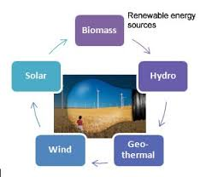
Class Website: http://aofscience.weebly.com

Mr. Gutierrez’s email: gutierrezbr@elizabeth.k12.nj.us

Packet |  | Followed All Classroom Policies
/80 | Completed Class Notes | / | Monday
/20 | Writing Name on Every Page | / | Tuesday
 |  | / | Wednesday
 |  | / | Thursday
 |  | / | Friday
/100 | Total Points | / | Total Points

Name of Environmental Scientist (Your Name):
_______________________________________________________________

Period: ___________

Table of Contents

Topic | Packet Page | Textbook Page
1. Biomass Energy | 3 – 5 | 551 - 553
2. Geothermal Energy | 6 – 8 | 553 - 555
3. Hydropower | 9 – 11 | 557 - 560
4. Solar Energy | 12 – 14 | 562 – 564
5. Wind Energy | 15 - 16 | 566 – 569
*Waste Management | 20 – 21 | 582 – 605

Date: _________________
Objective: SWBAT explain how biomass energy is used.

BIOMASS ENERGY

Energy derived from biomass is used for cooking, heating, powering motor vehicles, and generating electricity.

- Biomass is material—such as wood, manure, and grain—that makes up___________________________________________or comes from living organisms.

- Biomass energy, called __________________________, is produced by ____________________________________.

- Biomass energy can be used for heating, cooking, lighting, vehicle fuel, or electricity generation.

Sources of Biomass

SOLID | _______________, charcoal, manure, agricultural and timber waste, _____________________
GASES | _____________________________________produced by breakdown of waste in __________________ (where garbage is thrown)
LIQUID (BIOFUEL) | 1. Ethanol:  - Produced by fermentation of starches and sugar  - Mainly produced from ____________  2. Biofuel:  Produced from ________________________

THINK. PAIR. SHARE.

With a partner, take a few moments to discuss the benefits and costs of biomass energy.

BENEFITS | COSTS and DISADVANTAGES

Benefits and Costs of Biomass Energy

BENEFITS | COSTS and DISADVANTAGES
- ______________________________  - Can be produced by all nations | - Takes away land from food crops or _______________________  - ____________, _________________and desertification can result if plant biomass is harvested ______________________  - ______________ input is needed.  - Burning biomass indoors can lead to ________________________

Date: _________________
Objective: SWBAT describe how geothermal energy is harnessed and used.

GEOTHERMAL ENERGY
Steam and how water produced by geothermal energy can be used for generating electricity and for heating.

- Underground heat generated by ___________________________ and breakdown of radioactive elements

- Usually accessed by _______________________ below ground; __________________________________________, generating electricity.

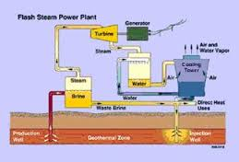

- Can be used directly by ______________________________ from its source into homes and businesses

- Ground source heat pumps use naturally temperate soil, a few feet underground, to _____________________________ and to cool them in summer.

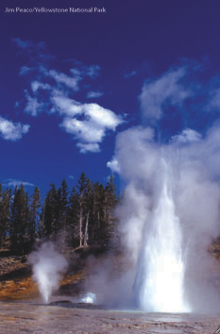

___________________ (shown above) erupt because of geothermal energy.

THINK. PAIR. SHARE.

With a partner, take a few moments to discuss the benefits and costs of geothermal energy.

Benefits and Costs of Geothermal Energy

BENEFITS | COSTS/DISADVANTAGES
Benefits and Costs of Geothermal Energy

BENEFITS | COSTS/DISADVANTAGES
- Causes much less air pollution than fossil fuels  - _______________________  _______________________ | - Not sustainable if _______________________________than it is naturally replenished  - Hot groundwater can contain _______________________________ or add to pollution.  - Some geothermal energy projects can ______________________________.  - Geothermal power plants _____________________________ in places with ______________ to geothermal energy.

Date: _________________
Objective: SWBAT explain how flowing water can be used to generate electricity.

ELECTRICITY FROM HYDROPOWER

The movement of water can be used to generate electricity.

- Hydropower is generated by ______________________________________________.

- Two basic approaches:
- ________________________________________and pushes turbines.

- _______________________________ is diverted through turbines.

- Naturally flowing water can lead to a ___________________supply of electricity. Dams provide ______________________ electricity but can _____________________ natural habitats.
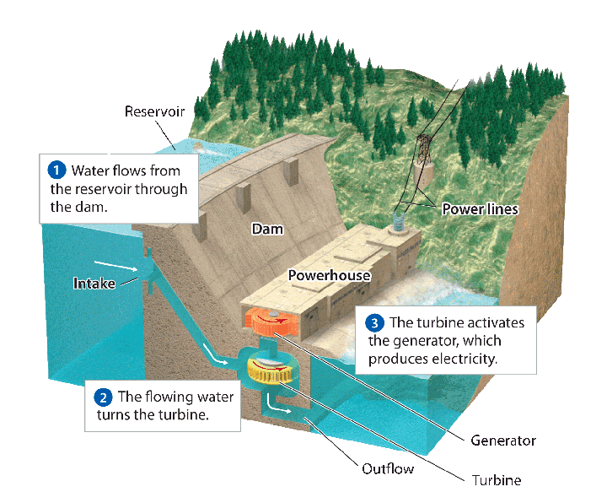

Benefits and Costs of Hydropower

BENEFITS | COSTS/DISADVANTAGES
- _______________________  - No air pollution or greenhouse gas emissions  - Yields relatively ________________electricity | - Dams ________________________ and affect organisms (especially fish).  - Dams _________________________________________, preventing it from reaching downstream.  - Building dams and reservoirs can __________________ people.

TIDAL ENERGY

- Electricity generated by the ___________________________________________

- Tidal waters push turbines in a dam.

- The best places to harness tidal energy have ________________________ in the heights of high and low tides.

- Generates _____________________________, but shore ecosystems can be negatively affected and very few locations are currently suitable.

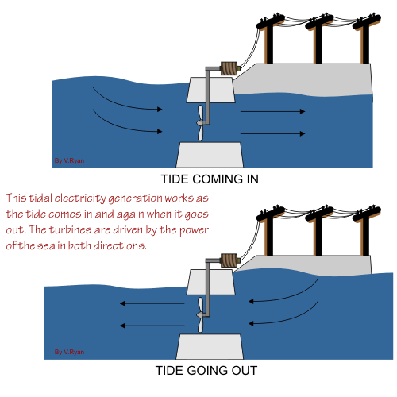

Date: _________________
Objective: SWBAT describe how solar energy is harnessed.

SOLAR ENERGY

The sun’s energy can be used to heat buildings and generate electricity.

Using Solar Energy for HEAT

- Passive solar heating: _________________ to efficiently __________________________________________________________; can be used to heat homes and businesses

- Active solar heating: Uses ____________________, such as ___________________, to capture, store, and distribute the sun’s energy

Using Solar Energy for ELECTRICITY

- Photovoltaic cells (solar panels): Convert ___________________________ directly into ___________________

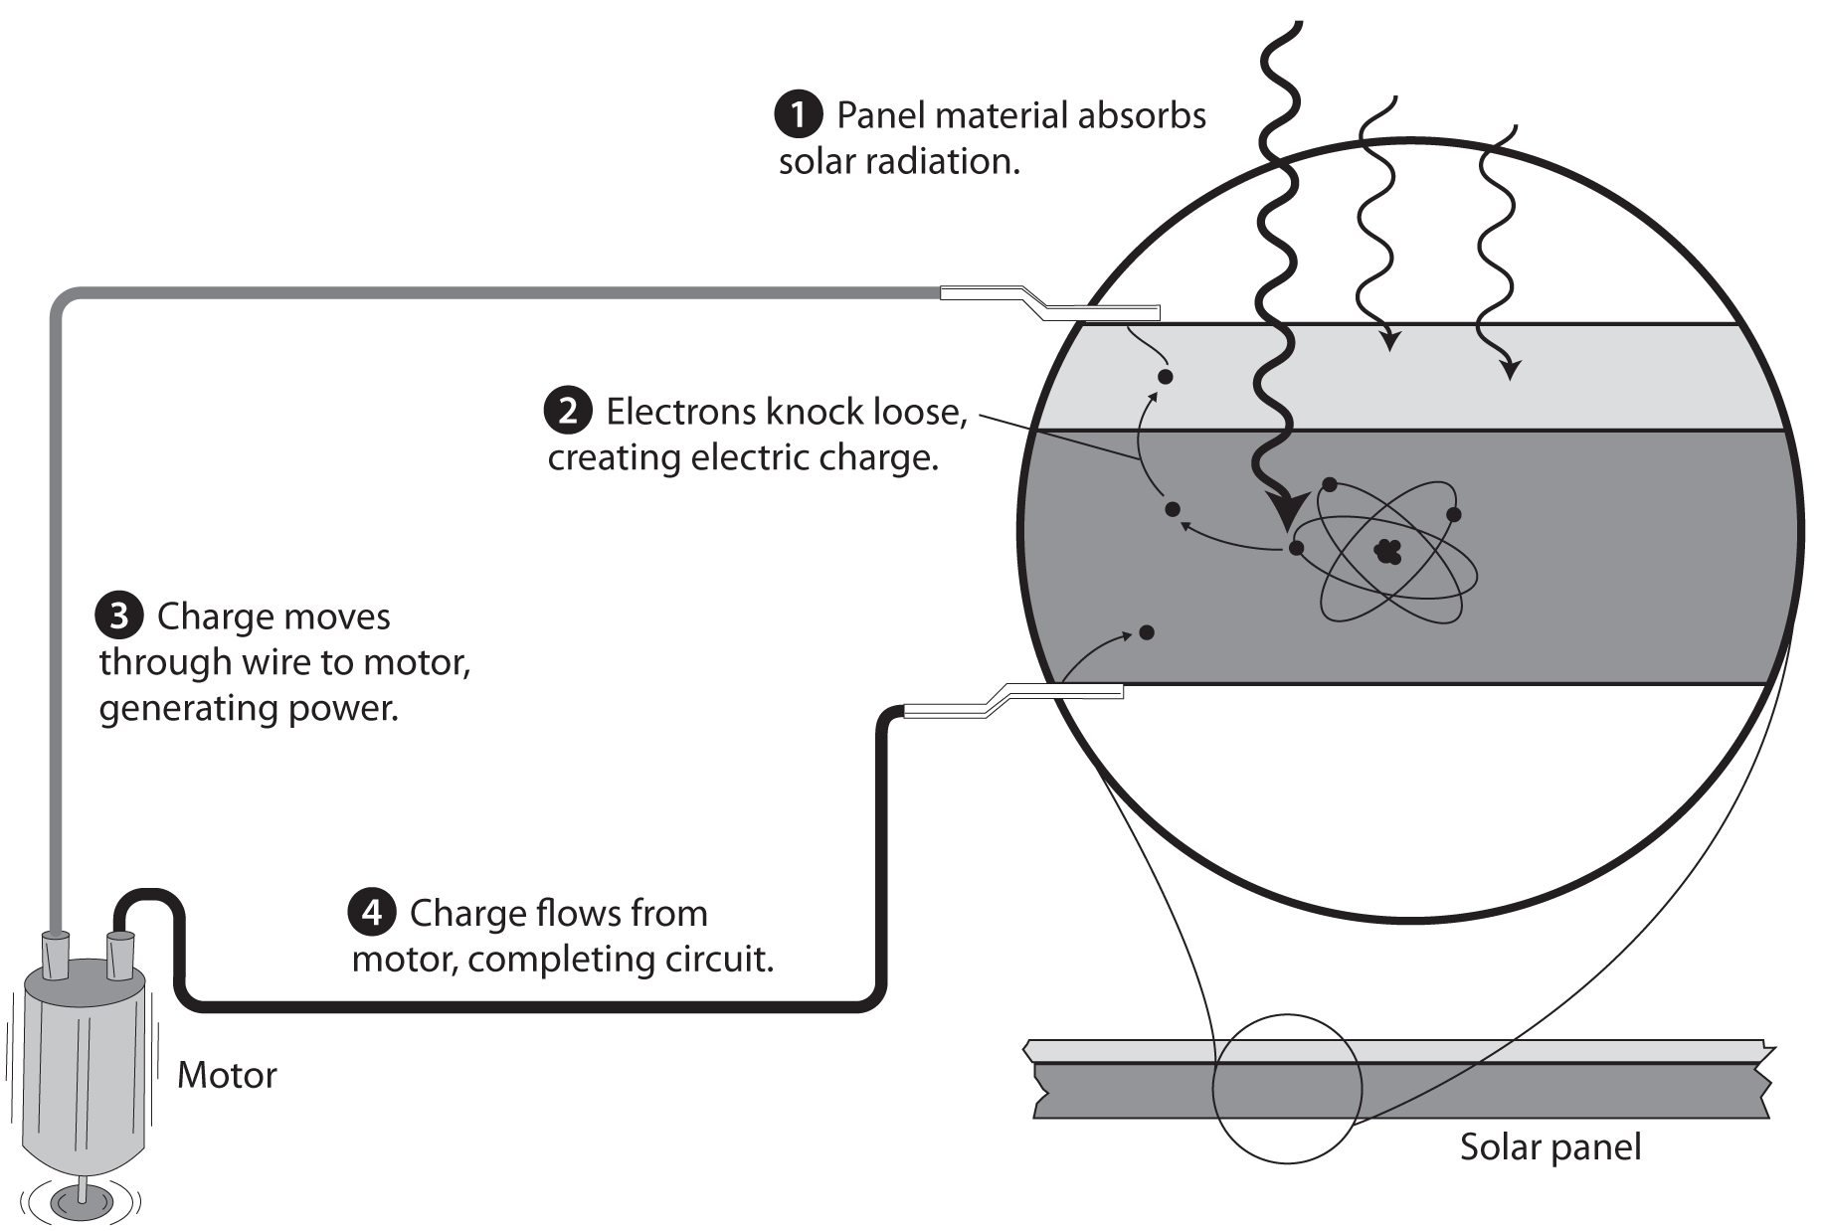

- Concentrating solar power: Uses__________________ to focus the sun’s rays on a vessel containing fluid; __________________________________________________ and generate electricity.

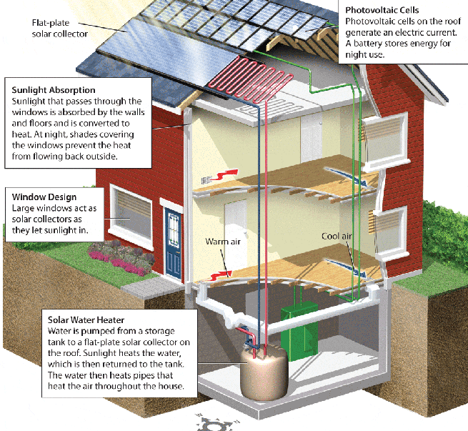

Date: _________________
Objective: SWBAT analyze the benefits and costs of solar energy.

Benefits and Costs of Solar Power

BENEFITS | COSTS/DISADVANTAGES
- _________________________  - Clean—no air or water pollution produced during operation  - Low maintenance devices  - New ___________ to make solar devices | - Some pollution during manufacture  - Many regions _______________________________  - Devices are __________________

Date: _________________
Objective: SWBAT explain how wind energy can be used to produce electricity.

WIND ENERGY

- Wind turbines (windmills) convert wind’s ___________________ to _________________.

- Wind turbines can be placed on _________________________.

- Turbines can be _____________ or built in ___________ called wind farms.

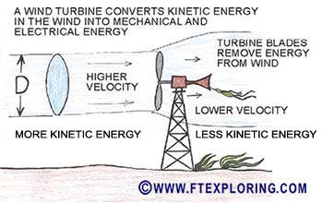

Date: _________________
Objective: SWBAT analyze the benefits and costs of wind energy.

Benefits and Costs of Wind Power

BENEFITS (Advantages) | COSTS (Disadvantages)
- No pollution or greenhouse gases produced during operation  - Under good wind conditions, produces far _________________________  - Relatively cheap to operate | - High startup costs  - Winds can be ____________  - Fastest winds are often not near population centers.  - Communities complain about the _______________ of wind farms.  - Can be harmful to _______________________

Renewable Energy Resources Summary

Use this as a guide to help you study the different types of renewable energy sources.

Type of Renewable Energy | How it Works | Pros | Cons
- Biomass
- Geothermal
- Hydropower
- Solar
- Wind
- Hydrogen Fuels

CHAPTER 19: Waste Management

What is waste?

- Any unwanted material or substance that results from a human activity or process
  - Municipal solid waste: From homes and businesses

  - Industrial waste: Resulting from manufacturing, agriculture, and mining

  - Hazardous waste: Toxic, reactive, flammable, and corrosive

    - E-waste: Contains heavy metals and toxic chemicals, but mostly treated as conventional solid waste

  - Wastewater: Includes used, discarded water and runoff

DISPOSING OF HAZARDOUS WASTE

- Landfills: Specifically designed to keep hazardous waste contained

- Surface impoundment: Liquid waste poured into shallow lined pits; water evaporates and solid waste is transported elsewhere

- Deep-well injection (see diagram below): Wastes injected into deep, confined porous rock layers
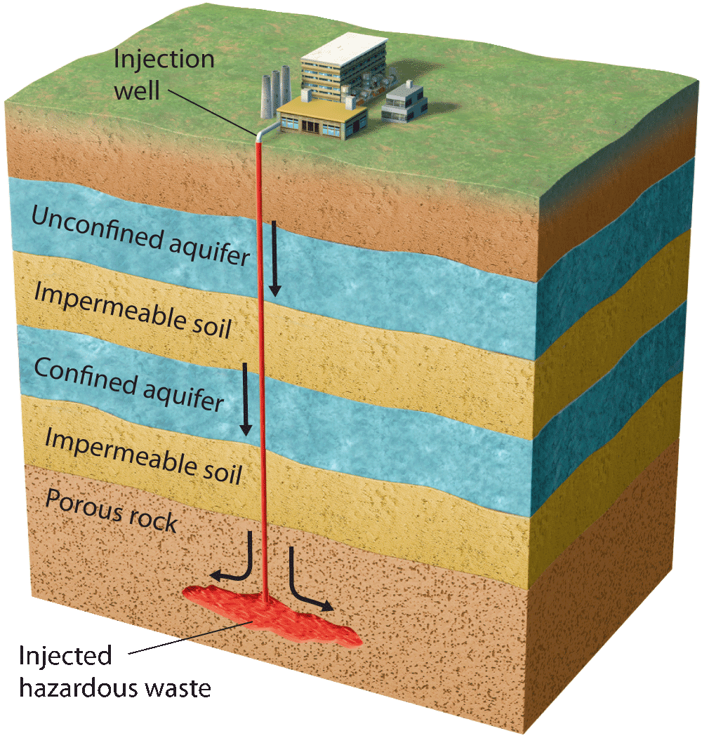

INCINERATION

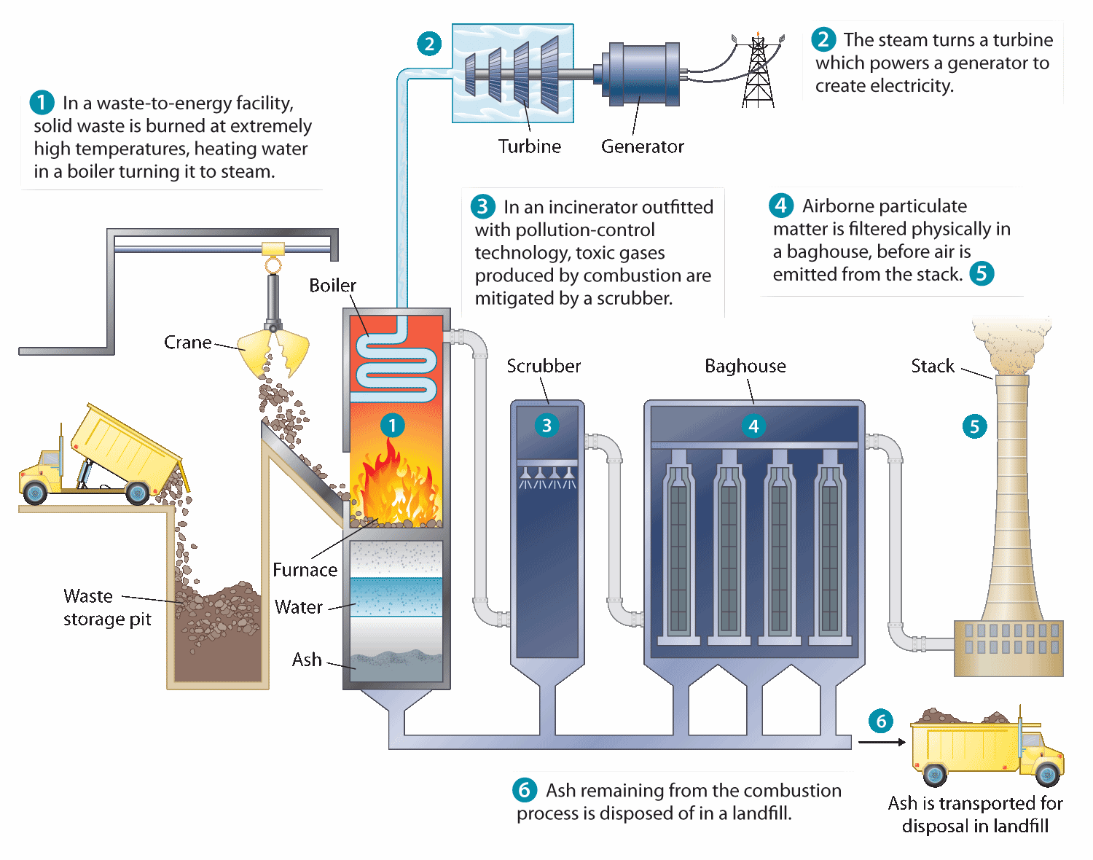

Benefits of Incineration | Costs of Incineration
- Incinerating waste reduces its weight by up to 75% and volume by up to 90%.  - Heat from burning trash can be used to generate electricity (waste-to-energy). | - Toxic ash must be disposed of.  - Dioxins, heavy metals, and PCBs can be created and released by burning waste.

Question to ponder: What do we need to do to make sure that we safely manage our hazardous waste from our households?

Make sure Mr. Gutierrez stamps/signs this by the end of the period. You CANNOT get the stamp/signature for a day later on. It is your responsibility to remind Mr. Gutierrez. You will NOT receive a stamp if you did not follow all classroom policies or actively work on the practice problems during the allotted class time. A stamp means you received all 10 points. No stamps means you’ve received zero points. If you completed some work, I may give you partial credit based on my discretion. If you are absent, write the date on the day you were absent and write the word “Absent.” DO NOT LOSE THIS SHEET!!! (If you lose this sheet, you will lose all of your participation points. NO EXCEPTIONS.)

Day of Week | Followed All Classroom Policies (Respectful, on time, prepared, engaged…) | Class work Participation
Monday | /10 | /10
Tuesday | /10 | /10
Wednesday | /10 | /10
Thursday | /10 | /10
Friday | /10 | /10

